HIV treatment uptake in Western Australia
2017
A report on HIV antiretroviral treatment provided to WA residents

Acknowledgements
We would like to thank the Pharmaceutical Benefits Scheme for providing the treatment data; Nasir Wabe, Heather-Marie Schmidt and Humaira Malik, (NSW Ministry of Health) and Mimi Liu (Epidemiology Branch, Department of Health, Western Australia) for their assistance in producing the data presented in this report.

Contributors/Editors

Epidemiology and Surveillance Program Communicable Disease Control Directorate Department of Health, Western Australia PO Box 8172 Perth Business Centre Western Australia 6849
Telephone: (08) 9388 4999
Facsimile: (08) 9388 4877
Web: ww2.health.wa.gov.au

Disclaimer
Every endeavour has been made to ensure that the information provided in this document was accurate at the time of writing. However, infectious disease testing and notifications data are continuously updated and subject to change. As no formal statistical testing has been conducted, some caution should be taken in interpreting differences and trends in this report.
Copyright to this material is vested in the State of Western Australia unless otherwise indicated. Apart from any fair dealing for the purposes of private study, research, criticism or review, as permitted under the provisions of the Copyright Act 1968, no part may be reproduced or re-used for any purposes whatsoever without written permission of the State of Western Australia.

Published by
This publication has been produced by the Department of Health, Western Australia.
Contents
Executive summary 3
Abbreviations 4
Introduction 5
Methods 5
Results 6
References 10

Executive summary
This report presents a descriptive analysis of HIV antiretroviral (ARV) treatments (“HIV treatment”) available on the Pharmaceutical Benefits Scheme (PBS) and provided to Western Australian (WA) residents in 2017. An estimate of treatment coverage among WA residents diagnosed with HIV is also presented for both years.
In 2017, 1760 WA residents were provided HIV treatment, a 15.7% increase from 2015 (1521 residents). The majority of people on HIV treatment in 2017 were male (78.3%) and aged 40 years and over (70.4%), which was similar to that reported in recent years. From 2015 to 2017, the estimated HIV treatment coverage among people diagnosed with HIV increased from 82.8% to 88.7%.
In 2017, the majority of people provided HIV treatment resided in the Perth metropolitan area (87.0%), and accessed treatment at a metropolitan pharmacy (93.2%). The most commonly dispensed HIV treatment regimen in 2017 was Tenofovir + Emtricitibine + Elvitegravir + Cobicistat, with the number of individuals on this regimen more than triple the number reported in 2015 (148 to 460 residents). Following the commencement of the Community Access HSD program on July 1, 2015, nearly all WA residents provided HIV treatment were prescribed under the new program. In 2017, most individuals provided HIV treatment were dispensed antiretrovirals at a public hospital pharmacy (91.6%).

Abbreviations
ARV | Antiretroviral
DoH | Department of Health, Western Australia
DVA | Department of Veterans’ Affairs
HIV  HIV Treatment | Human immunodeficiency virus  Antiretroviral treatment for HIV, prescribed and dispensed under the Pharmaceutical Benefits Scheme (PBS)
HSD | Highly Specialised Drugs
PBS | Pharmaceutical Benefits Scheme
WA | Western Australia

Introduction
This report will present data on the number of Western Australian (WA) residents who were dispensed antiretroviral (ARV) treatment for HIV, hereafter referred to as “HIV treatment”, in 2017. This includes trends by patient demographics, estimated treatment coverage, regimen and dispensing characteristics. Comparisons with HIV treatment data from 2015 and 2016 will also be presented.

Methods
A descriptive analysis was conducted on HIV treatment dispensed under the Pharmaceutical Benefits Scheme (PBS), to Western Australian (WA) residents in 2017 (See section Pharmaceutical Benefits Scheme (PBS) Data).
The analysis was conducted using data provided by the PBS. The HIV treatment data were presented by patient sex and age group, area of residence, treatment regimen, and the pharmacy location of where the treatment was dispensed. Estimated treatment coverage among WA residents living with diagnosed HIV was calculated using data from the PBS and the WA DoH HIV notifications database (See section: HIV treatment coverage methodology).
Pharmaceutical Benefits Scheme (PBS) data
The PBS provides access to a number of government subsidised prescription medicines to Australian residents with a Medicare card. HIV treatment is subsidised under the Section 100 Highly Specialised Drugs (HSD) Program of the PBS.
The PBS provided a de-identified extract of data showing the number of HIV treatments dispensed to WA residents from 1 January 2015 to 31 December 2017. The data were extracted by selected ARV treatments or specific PBS item codes or indications, where necessary. The indication was identified from the Authority Code or Streamlined Authority Code where available. WA residents were identified from the patient postcode as recorded on the Medicare Enrolment file at the date of supply.
Using a confidentialised patient identification number, the number of individuals dispensed HIV treatment in 2017 was calculated from the PBS data extract. This was then compared to the number of individuals dispensed treatment in 2015 and 2016. The data were analysed using the following PBS variables: patient date of birth, patient sex, patient postcode, patient category, pharmacy type, prescriber ID confidentialised, prescriber derived major speciality, date of prescribing, date of supply, PBS item code, drug name, program code, streamlined authority code and authority code
HIV treatment coverage methodology
In this report, HIV treatment coverage was calculated by dividing the number of WA residents on HIV treatment by the estimated number of people living with diagnosed HIV in WA. This estimate was derived by extracting the total number of HIV cases from the WA DoH HIV Notifications Database. All cases reported to the WA DoH HIV Notifications Database as having died, left WA, or notified as an overseas visitor, overseas student, interstate resident or temporary visa holder (including temporary work visas) were excluded from the analysis. However, the WA DoH is not notified when a case leaves WA and it is also likely that some cases who have died were not reported to the WA DoH HIV Notifications Database. Cases diagnosed interstate who moved to WA were not included in the analysis. A χ² test was conducted to test the statistical significance of differences between treatment coverage from 2015 to 2017.

Results
HIV treatment by patient demographics
In 2017, 1,760 WA residents were provided HIV treatment subsidised by the Pharmaceutical Benefits Scheme (PBS), a 15.7% increase compared to the number of residents provided treatment in 2015 (n=1,521) (Table 1). Similar to the previous two years, the majority of residents provided HIV treatment in 2017 were male (78.3%) (Table 1) and aged 40 years or older (70.4%) (Table 2).
The increase in the number of WA residents provided HIV treatment was reported for males and females and across most age groups. The largest increase in treatment uptake was among people aged 60 years and over, where the number of people provided HIV treatment increased by 32.5% between 2015 and 2017 (Table 2).

Table 1 Number and proportion of individuals provided HIV treatment by sex, WA residents 2015 to 2017

Table 2 Number and proportion of individuals provided HIV treatment by age group, 2015 to 2017

HIV treatment coverage
Corresponding with the increase in the number of residents on HIV treatment, estimated treatment coverage among those diagnosed with HIV rose from 82.8% in 2015 to 88.7% in 2017 (p < 0.05) (Figure 1). This was just under the National HIV Strategy 2014-2017 target to achieve 90% treatment uptake in people living with HIV¹

Figure 1 Number of WA residents provided ART for HIV and Estimated HIV treatment coverage among WA residents diagnosed with HIV
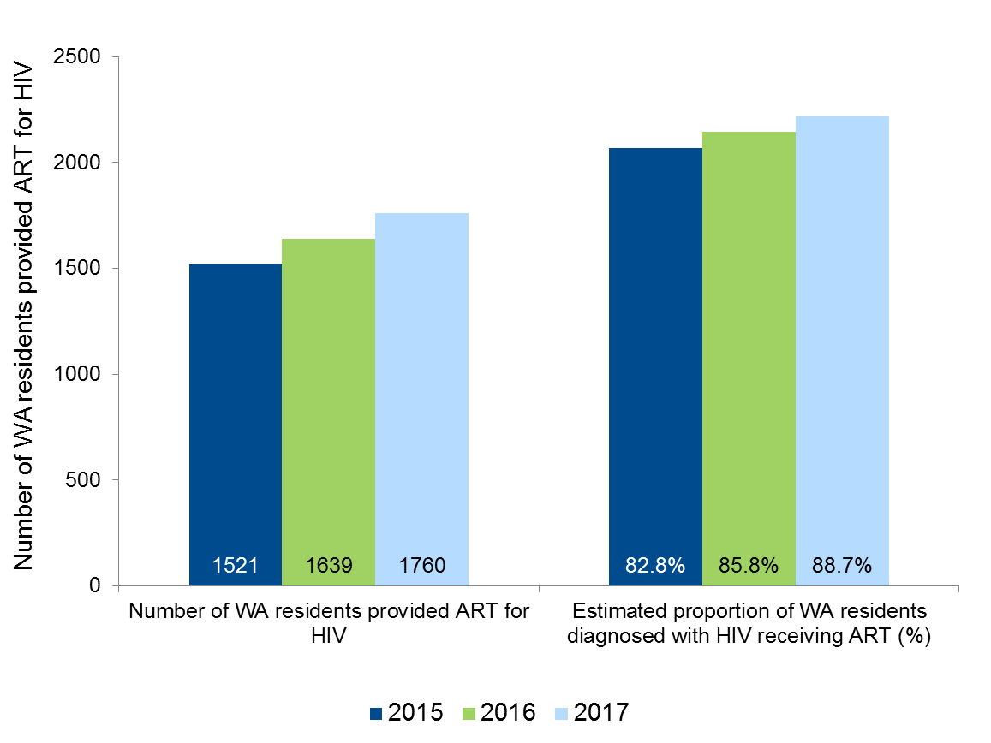

Place of residence and pharmacy location
In 2017, metropolitan residents continued to make up the vast majority of people who were provided HIV treatment (Table 3). While non-metropolitan residents continued to make up a small proportion of people on HIV treatment in WA, this number did increase by 27.4% between 2015 (n=179) and 2017 (n=228) (Table 3). However, in all three reporting years, less than 1% of WA residents provided HIV treatment were dispensed treatment at a WA pharmacy outside the metropolitan area (Table 4). A small proportion of WA residents on HIV treatment were dispensed treatment by a pharmacy located outside WA, although this figure increased in 2017 (Table 4).

Table 3 Number, proportion and rate of WA residents provided HIV treatment by place of residence, 2015 to 2017

Table 4 Number and proportion of WA residents provided HIV treatment by pharmacy location, 2015 to 2017

HIV treatment regimens and dispensing characteristics
In 2017, just over a quarter of individuals on HIV treatment were provided with the Tenofovir + Emtricitibine + Elvitegravir + Cobicistat regimen (26.1%; n=460). This was followed by the Dolutegravir + Abacavir + Lamivudine regimen, which was provided to around 20% of individuals on HIV treatment in 2017 (n=357). Both regimens are offered as a single tablet and the number of individuals provided these regimens has more than tripled since 2015 (Table 5).

Table 5 Number and proportion of WA residents dispensed HIV treatment by regimen, 2015 to 2017
Following the commencement of the Community Access HSD program on July 1, 2015, almost all prescriptions were dispensed under this new program in 2016 (99.7%) and 2017 (99.5%)(Table 6). While the Community Access HSD prescription allows a script to be filled by a community pharmacy, most people continued to have their HIV treatment dispensed at a public hospital pharmacy in 2017 (91.6%). Nevertheless, the number of individuals who accessed HIV treatment at a community pharmacy in 2017 (n=148) was more than four times the number reported in 2015 (n=33) (Table 7).

Table 6 Number and proportion of WA residents provided HIV treatment by program code, 2015 to 2017

Table 7 Number and proportion of WA residents provided HIV treatment by pharmacy type, 2015 to 2017
Similar to previous years, the majority of people who were provided HIV treatment in 2017 were prescribed treatment as a General patient under the Pharmaceutical Benefits Scheme (PBS) beneficiary status categories (71.5%) (Table 8).

Table 8 Number and proportion of WA residents provided HIV treatment by patient category
Note: The level of subsidy under the PBS depends on the patient’s beneficiary status. Concessional status is for people who are eligible to receive government entitlements, including pensioners and low-income earners. Eligible veterans and their dependents holding a Department of Veteran’s Affairs (DVA) health card are also entitled to medicines and additional pharmaceutical items at concessional rates under the Repatriation PBS. All other individuals are considered general beneficiaries and have a higher co-payment threshold. There were two people who were Repatriation PBS patients and these have been excluded from this table. The age groups <20 years and 20-29 years were merged due to small numbers.

References
- Australian Government Department of Health (2014). Seventh National HIV Strategy. ACT: Department of Health, Commonwealth of Australia


This document can be made available in alternative formats
on request for a person with a disability.
© Department of Health 2017
Copyright to this material is vested in the State of Western Australia unless otherwise indicated. Apart from any fair dealing for the purposes of private study, research, criticism or review, as permitted under the provisions of the Copyright Act 1968, no part may be reproduced or re-used for any purposes whatsoever without written permission of the State of Western Australia.

