Example of MVEV Case Investigation Form

Notification ID:

Date and time notified:

Notified by: |  | Organisation/Hospital: |  | Phone:

Final Classification |  | Confirmed |  | Probable |  | Rejected

Date questionnaire completed:

Person(s) interviewed

Case
Parent/guardian, (specify)
Spouse/other family member (specify)
General Practitioner (name)
Treating Doctor (name)
Other (specify)

Please indicate who completed this form:

Public Health Officer
EHO (name and Local Govt))
Other (specify)

Section 1: Case Details

First Name: |  | Surname:

Gender: |  | M |  | F |  | Date of birth (day/month/year): |  | / |  | /

Is the case of Aboriginal or Torres Strait Islander origin:

 | Non Indigenous |  | Aboriginal |  | Torres Strait Islander (TSI)

 | Aboriginal and TSI |  | Unknown

Residential address (not PO box):

Town/Suburb: |  | State: |  | Postcode: |  | Country:

Phone (home) |  | Phone (mobile) |  | Phone (Work)

Country of birth: |  | Year of arrival:

Occupational:

Occupation requires work mostly: |  | indoors |  | Outdoors

Status:

 |  | Alive
 |  | Died due to notifiable disease – date: |  |  |  |  |  |  |  |  |  |  | / |  |  | /
 |  | Died due to other/unknown cause – date: |  |  |  |  |  |  |  |  |  |  | / |  |  | /
 |  | Unknown

Doctors details: General Practitioner

Doctor name: |  | Clinic name:

Address | :

Phone (work) |  | Fax (work) |  | email

Section 2: Laboratory Criteria

Name of laboratory:

Date result available: |  | / |  | /

Specimen collection date: |  | / |  | /

Type(s) of specimen:

Blood
Cerebrospinal fluid
Other:

Results:

 | Yes | No | Equiv | Specimen Type
MVE virus isolation
Nucleic acid test: PCR +ve
MVEV IgG +ve (initial bleed)

 | Yes | No | Equiv | Pending | Bleed date  1 | Bleed date  2 | Titre  (serology)
MVEV IgG +ve (initial bleed)
MVEV IgG +ve (second bleed)
MVEV IgM +ve (encephalitic illness Y / N)
Virus neutralisation serology

Confirmation of second laboratory: |  | Yes |  | No

If yes, name of second laboratory
Confirmation of laboratory result by second arbovirus reference laboratory is required if the case occurs in areas of Australia not known to have established enzootic/endemic activity or regular epizootic/epidemic activity, see case definitions available from the Health Website (http://www.health.gov.au/internet/main/publishing.nsf/Content/cda-surveil-nndss-casedefs-cd_mve.htm)

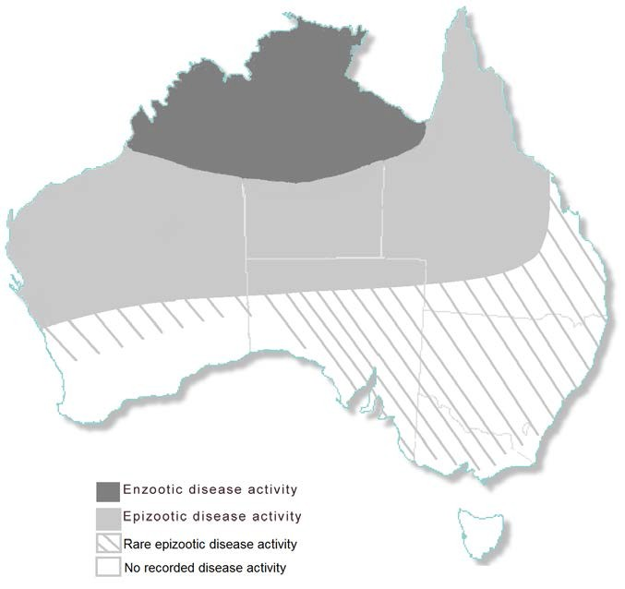
Figure 1. MVEV enzootic and epizootic regions in Australia

Has the case tested positive for MVEV before |  | Yes |  | No

If yes, give details:

Has the case tested positive for any other arbovirus before? |  | Yes |  | No

If yes, give details:

Section 3: Illness details

Date of onset (D/M/Y): |  | / |  | / |  |  | Date of first consultation |  | / |  | /

Total duration of illness: |  | days |  | hours

Symptom Profile

No symptoms |  | Yes |  | No |  | Unknown
Nausea |  | Yes |  | No |  | Unknown
Dizziness |  | Yes |  | No |  | Unknown
Headache |  | Yes |  | No |  | Unknown
Tiredness |  | Yes |  | No |  | Unknown
Neck Stiffness |  | Yes |  | No |  | Unknown
Photophobia |  | Yes |  | No |  | Unknown
Fever |  | Yes |  | No |  | Unknown
Rash |  | Yes |  | No |  | Unknown
Muscle aches and pains |  | Yes |  | No |  | Unknown
Impaired consciousness |  | Yes |  | No |  | Unknown
Confusion |  | Yes |  | No |  | Unknown
Difficulty walking |  | Yes |  | No |  | Unknown
Young children: Drowsiness/floppy/irritability |  | Yes |  | No |  | Unknown

Other (specify)

History of illness from case or proxy:

History of illness from treating doctor:

Section 4: Hospital presentation

Did the case present to hospital? |  | No |  | Yes |  | Date presented to hospital |  | / |  | /

Admitted to hospital: |  | No |  | Yes

If admitted, hospital name(s): |  | UR no:

Date presented to hospital (D/M/Y) |  | / |  | /

Date discharged (D/M/Y) |  | / |  | /

Treating doctor / Unit:

Discharge summary requested: |  | No |  | Yes | Date |  | / |  | /

Section 5: Exposure period

Calculated exposure period (Onset – 28 days) to (Onset – 5 days) |  | / |  | / |  | to |  | / |  | /

Did the case travel in the 4 weeks before onset of symptoms? |  | No |  | Yes |  | Within the State |  | Interstate |  | Overseas

During the exposure period, please indicate all suburb/s or town/s (Australian and overseas) in which the person resided, worked or visited.

Leave blank if information not available or unknown

 | Address/Suburb/Town/Country | Dates  (arrival and departure) | Activity at this place | Building features | Noticed mosquitoes | Recall being bitten by mosquitoes here?
1. |  |  | Reside/Work/Visit | Screens/Aircon | Yes No | Yes No
2. |  |  | Reside/Work/Visit | Screens/Aircon | Yes No | Yes No
3. |  |  | Reside/Work/Visit | Screens/Aircon | Yes No | Yes No
4. |  |  | Reside/Work/Visit | Screens/Aircon | Yes No | Yes No
5. |  |  | Reside/Work/Visit | Screens/Aircon | Yes No | Yes No
6. |  |  | Reside/Work/Visit | Screens/Aircon | Yes No | Yes No
7. |  |  | Reside/Work/Visit | Screens/Aircon | Yes No | Yes No
8. |  |  | Reside/Work/Visit | Screens/Aircon | Yes No | Yes No

Notes to the interviewer: Where possible ask the person to identify the location down to a street or lot number or a particular part of a recreational area (e.g. wetland, nature reserve, golf course, etc).

Section 6: Further details of location/activities/behaviour whilst in the place they were most likely to have acquired their infection

What activities were they doing (camping/fishing/gardening)?

What type of accommodation (tents/hotel/hostel)?

Where did they notice the mosquitoes (indoors/outdoors, near water bodies, in the bush, etc)?

Did the case report use: (a) of personal mosquito repellent? |  | Yes |  | No | (b) protective clothing |  | Yes |  | No | (c) mosquito nets |  | Yes |  | No

Does the case know of other persons who have been to the same place who have become ill? |  | Yes |  | No

If yes, seek further details:

Section 7: Co-exposed

Co-exposed can be defined as persons who have had the same exposure/s as the case including household members and persons who travelled with the case.

Name, address and phone number | Age | Recent MVE-like illness
 |  | Yes No
 |  | Yes No
 |  | Yes No
 |  | Yes No
 |  | Yes No
 |  | Yes No
 |  | Yes No

Section 8: Public Health Action

Mosquito precautions discussed: |  | Yes |  | No

Fact sheet sent: |  | Yes |  | No

Other:

Section 9: Interviewer

Name:

Signature:

Date |  | / |  | /

