Foodborne disease surveillance and outbreak investigations in Western Australia 2013 annual report

Enhancing foodborne disease surveillance across Australia


OzFoodNet, Communicable Disease Control Directorate
Acknowledgments

Acknowledgement is given to the following people for their assistance with the activities described in this report: Mr Brian MacKenzie, Mr Damien Bradford, Ms Lyn O’Reilly, Ms Jenny Green, Mr Ray Mogyorosy and the staff from the enteric, PCR and food laboratories at PathWest Laboratory Medicine WA; Mr Stan Goodchild, Ms Anna Anagno and other staff from the Food Unit of the Department of Health, Western Australia; Public Health Nurses from the metropolitan and regional Population Health Units; and Local Government Environmental Health Officers.

Contributors/Editors

Barry Combs, Sarojini Monteiro, Nevada Pingault

Communicable Disease Control Directorate
Department of Health, Western Australia
PO Box 8172
Perth Business Centre
Western Australia 6849

Email: OzfoodnetWA@health.wa.gov.au

Telephone: (08) 9388 4999

Facsimile: (08) 9388 4877

Web:
OzFoodNet WA Health www.public.health.wa.gov.au/3/605/2/ozfoodnet_enteric_infections_reports.pm
OzFoodNet Department of Health and Ageing
www.ozfoodnet.gov.au/

Disclaimer:

Every endeavour has been made to ensure that the information provided in this document was accurate at the time of writing. However, infectious disease notification data are continuously updated and subject to change.

PUBLISHED BY
This publication has been produced by the Department of Health, Western Australia.

Executive summary
This report is a summary of enteric disease surveillance activities and outbreak investigations in Western Australia (WA) in 2013.
Enteric disease causes a large burden of illness in the WA community. In WA, there are 16 enteric infections that are notifiable to the Department of Health. The Department of Health through OzFoodNet (OFN) and other agencies conducts surveillance and investigates outbreaks so that targeted interventions can be used to help prevent further transmission.
In WA, there was 4060 enteric disease notifications in 2013 with a rate of 164 cases per 100 000 population which is 9% lower than the average for the previous five years. The age group with the highest rate was <1-4 years with a rate of 493 cases per 100 000 population. Aboriginal people have 55% higher enteric disease infection rates than non-Aboriginal people. The Kimberley region has a rate nearly 3 times higher (606 per 100 000 population) than any other region. Of the notified enteric infections with a know place of acquisition, 69% reported acquiring their infection in WA, 30% reported overseas travel and 1% reported interstate travel. Of enteric notifications reporting overseas travel, most (55%) had travelled to Indonesia.
Figure A: WA enteric diseases for 2013 by disease; number of notifications

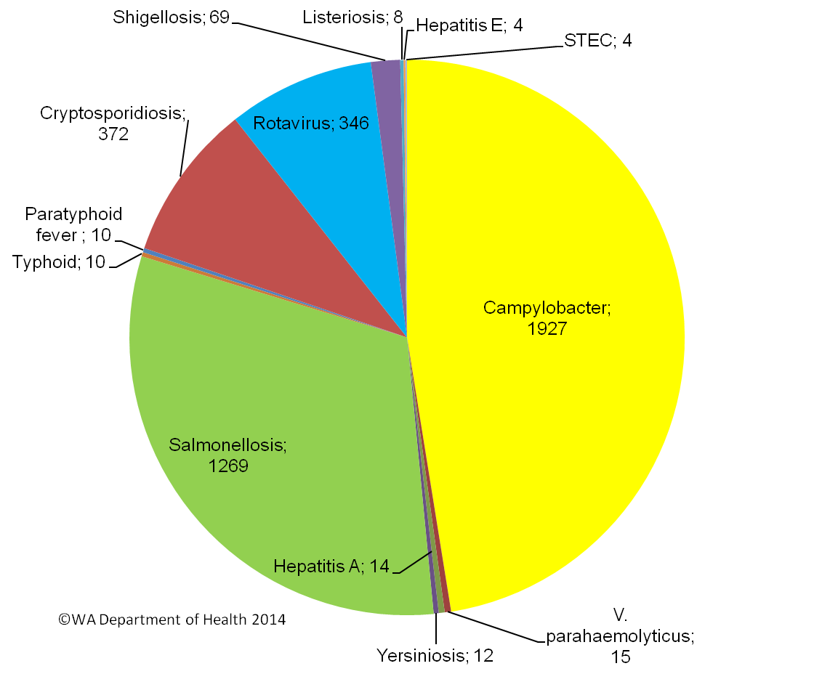
Campylobacteriosis was the most (n=1927) commonly notified enteric disease in 2013 followed by salmonellosis (n=1269), cryptosporidiosis (n=372) and rotavirus (n=346) (Figure A). Most enteric diseases had similar or lower rates of notifications compared to the previous five years. The majority (ranging from 55% to 90%) of people who had one of the top four enteric diseases, had acquired their illness in WA.
Foodborne and suspected foodborne outbreaks
In 2013, there were 13 outbreaks of foodborne or suspected foodborne disease investigated in WA that caused at least 185 cases of illness (Figure B). Four of these outbreaks were caused by Salmonella species, two by Clostridium perfringens, two by norovirus, one each by Listeria and hepatitis A and three outbreaks the infectious agent or toxin was unknown. The largest foodborne outbreak in 2013 was caused due to an unknown infectious agent but illness was similar to a norovirus infection. In this outbreak most people infected had consumed duck pancakes prior to illness.
Of the 13 outbreaks, there were four outbreaks were a food was implicated which included a range of foods such as duck pancakes, chicken curry, eggs and salads. Among outbreaks in the previous five years when a food was implicated, dishes containing eggs (8/30) was the most common food vehicle.
Figure B: Foodborne outbreaks investigated in WA by causative pathogen
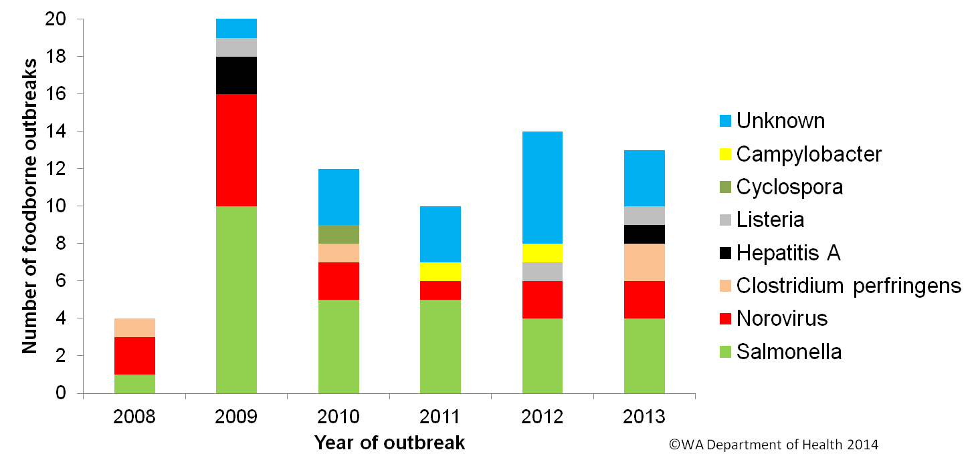
Non foodborne enteric disease outbreaks
Non-foodborne enteric disease outbreaks and outbreaks with unknown mode of transmission are a major cause of illness especially in institutions such as residential care facilities (RCF). There were 119 non-foodborne outbreaks reported in 2013 which resulted in 2459 ill people, 35 hospitalisations and 10 deaths. Most of these outbreaks were in RCF (71%) and due to person to person transmission (76%). Of those outbreaks with a known cause, most were due to norovirus (94%).
Table of contents
Executive summary - 3 -
List of Tables - 6 -
List of Figures - 6 -
1. Introduction - 8 -
2. Data sources and methods - 10 -
2.1. Data sources - 10 -
2.2. Data changes - 11 -
2.3. Data Collection by Aboriginality - 11 -
2.4. Regional Boundaries - 11 -
2.5. Calculation of rates - 11 -
2.6. Definitions: - 12 -
3. Site activities including prevention measures during the year - 12 -
4. Incidence of specific enteric diseases - 15 -
4.1. Campylobacteriosis - 15 -
4.2. Salmonellosis - 18 -
4.1. Cryptosporidiosis - 22 -
4.2. Rotavirus infection - 24 -
4.3. Shigellosis infection - 26 -
4.4. Hepatitis A virus infection - 29 -
4.5. Typhoid and Paratyphoid fever - 30 -
4.6. Listeriosis - 30 -
4.7. Vibrio parahaemolyticus infection - 31 -
4.8. Yersinia infection - 31 -
4.9. STEC infection - 32 -
4.10. Hepatitis E - 32 -
4.11. Cholera, Botulism and HUS - 32 -
5. Gastrointestinal disease outbreaks and investigations - 32 -
5.1. Foodborne/suspected foodborne outbreaks - 32 -
5.1. Outbreaks due to non-foodborne transmission or with an unknown mode of transmission -37 -
5.2. Cluster investigations -41 -
6. OzFoodNet WA research projects -42 -
6.1. Cryptosporidium project -42 -
6.2. Review of Guidelines for the Management of Gastroenteritis Outbreaks in Residential Care Facilities.................................................................................................-43-
6.3. Joint co-ordination of national case series study of Salmonella Typhimurium PT 193 ....................................................................................-43-
6.4. National descriptive study of Salmonella Enteritidis -43 -
7. References -44 -
Appendix 1: Number of notifications, notification rate and ratio of current to historical mean by pathogen/condition, 2008 to 2013, WA -49 -

List of tables
Table 1. Number and proportion of the top 10 Salmonella serotypes notified in WA, 2013, with comparison to the 5-year average..................................................................- 21 -
Table 2 Foodborne and suspected foodborne outbreaks, 2013 -36-
Table 3. Outbreaks due to non-foodborne transmission or unknown mode of transmission in WA by setting and agent, 2013................................................................-39-
Table 4. Cluster investigations in WA by month investigation started, setting and agent, 2013 -42-

List of figures
Figure 1. Number of cases of campylobacteriosis by year and month of onset, WA, 2008 to 2013. - 16 -
Figure 2. Campylobacteriosis notification rates by sex, WA, 2008 to 2013 - 17 -
Figure 3: Age-specific notification rates for campylobacteriosis by sex, WA, 2013 - 17 -
Figure 4. Campylobacteriosis notification rates by region and Aboriginality, WA, 2013 - 18 -
Figure 5. Number of cases of salmonellosis by year and month of onset, WA, 2008 to 2013 - 19 -
Figure 6. Age-specific notification rates for salmonellosis by sex, WA, 2013 - 19 -
Figure 7. Salmonellosis notification rates by region and Aboriginality, WA, 2013 - 20 -
Figure 8. Number of cases of S. Enteritidis by year of onset, WA, 2008 to 2013 - 21 -
Figure 9. Proportion of salmonellosis cases acquired overseas, by year of onset, 2008 to 2013 - 22 -
Figure 10. Number of cases of cryptosporidiosis by year and month of onset, WA, 2008 to 2013 - 22 -
Figure 11. Age-specific notification rates for cryptosporidiosis by sex, WA, 2013 - 23 -
Figure 12. Cryptosporidiosis notification rates by region and Aboriginality, WA, 2013 - 24 -
Figure 13. Number of cases of rotavirus infection by year and month of onset, WA, 2008 to 2013 - 25-
Figure 14. AAge-specific notification rates for rotavirus by sex, WA, 2013 age-specific notification rates for rotavirus by sex, WA, 2012 - 25-
Figure 15. Rotavirus notification rates by region and Aboriginality, WA, 2013 - 26-
Figure 16. Number of cases of shigellosis by year and month of onset, WA, 2008 to 2013 - 27-
Figure 17. Age-specific notification rates for shigellosis by sex, WA, 2013 - 27-
Figure 18. Shigellosis notification rates by region and Aboriginality, WA, 2013 - 28-
Figure 19. Year of onset and public health region of residence, for Aboriginal and non-Aboriginal shigellosis cases - 28-
Figure 20. Place of acquisition for shigellosis cases, 2008 to 2013 - 29-
Figure 21. Place of acquistion for hepatitis A cases, 2008 to 2013 - 30-
Figure 22. Notifications of listeriosis showing non-pregnancy related infections and deaths, and materno-foetal infections and deaths, WA, 2008 to 2013. - 31-
Figure 24. Number of gastroenteritis outbreaks designated as non-foodborne or with unknown mode of transmission reported in WA, in 2013 -38-
Figure 25. Average number of gastroenteritis outbreaks due to suspected person to person transmission for specific months for the period 2008 to 2013 in WA. -40-

Introduction
It has been estimated that there are 5.4 million cases of foodborne illness in Australia each year and that the cost of this illness is estimated at $1.2 billion per year¹. This is likely to be an underestimate of the cost of enteric illness in Australia as not all enteric infections are caused by foodborne transmission. Other modes of transmission are also very important causes of enteric infection including person to person, animal to person and waterborne transmission. Importantly, most of these infections are preventable through interventions at the level of primary production, commercial food handling, households and institution infection control.
This report describes Western Australian enteric disease surveillance and investigations carried out in 2013 by OzFoodNet WA (OFN) and other Western Australian Department of Health agencies. Most of the data presented in this report is derived from enteric disease notifications from doctors and laboratories received by the Department of Health, WA (WA Health) and are likely to underestimate the true incidence of disease. This data nevertheless remain the most important information on incidence of these infections for surveillance purposes in WA. In addition, norovirus which is not notifiable, is the cause of a large burden of illness in RCF and also in the general community.
OFN is part of the Communicable Disease Control Directorate (CDCD) of WA Health. OFN in Western Australia is also part of a National OFN network funded by the Commonwealth Department of Health and Ageing ². The mission of OFN is to enhance surveillance of foodborne illness in Australia and to conduct applied research into associated risk factors. The OFN site based in Perth is responsible for the whole of WA, which has a total population of approximately 2.4 million. Collaboration between states and territories is facilitated by circulation of fortnightly jurisdictional enteric surveillance reports, monthly teleconferences, tri-annual face-to-face meetings and through the informal network. This network also includes communication and consultation with Food Standards Australia New Zealand, the Commonwealth Department of Health and Ageing, the National Centre for Epidemiology and Population Health, the Communicable Diseases Network of Australia (CDNA) and the Public Health Laboratory Network.
The primary objectives of OFN nationally are to:
- estimate the incidence and cost of foodborne illness in Australia,
- investigate the epidemiology of foodborne diseases, by enhancing surveillance and conducting special studies on foodborne pathogens,
- collaborate nationally to coordinate investigations into foodborne disease outbreaks, particularly those that cross State, Territory and country borders,
- train people to investigate foodborne illness.
On a local level, OFN WA conducts surveillance of enteric infections to identify clusters and outbreaks of specific diseases and conducts epidemiological investigations to help determine the cause of outbreaks. OFN WA also conducts research into the risk factors for sporadic cases of enteric diseases and develops policies and guidelines related to enteric disease surveillance, investigation and control. OFN WA regularly liaises with staff from the Population Health Units (PHUs), the Food Unit (FU) in the Environmental Health Directorate of WA Health; and the Food Hygiene, Diagnostic and Molecular Epidemiology laboratories at PathWest Laboratory Medicine WA.
CDCD maintains and coordinates the WA notifiable disease surveillance system (WANIDD) and provides specialist clinical, public health and epidemiological advice to all PHUs. The WA notifiable diseases surveillance system relies on the mandatory reporting by doctors and laboratories for the surveillance of 16 notifiable enteric diseases and syndromes.
PHUs are responsible for public health activities, including communicable disease control, in their WA administrative health regions. There are 9 PHUs in WA: North Metropolitan, South Metropolitan, Kimberley, Pilbara, Midwest and Gascoyne, Wheatbelt, Goldfields, SouthWest, and Great Southern. The PHUs monitor RCF gastroenteritis outbreaks and provide infection control advice. The PHUs also conduct follow up of single cases of important enteric diseases including typhoid, paratyphoid, hepatitis A and E, cholera and Shigella dysenteriae. OFN will also assist with the investigation of these enteric diseases if there is a cluster and/or they are locally acquired, and will investigate RCF outbreaks if they are suspected to be foodborne.
The FU liaises with Local Government (LG) Environmental Health Officers (EHO) during the investigation of food businesses, and coordinates food business investigations when multiple LGs are involved.
The Food Hygiene, Diagnostic and Molecular Epidemiology laboratories at PathWest Laboratory Medicine WA provide public health laboratory services for the surveillance and investigation of enteric disease.

Data sources and methods

Data sources
Data on WA cases of notifiable enteric diseases were obtained from WANIDD. The notifications contained in WANIDD are received from medical practitioners and pathology laboratories under the provisions of the Health Act 1911 and subsequent amendments, and are retained in WANIDD if WA (for diseases not nationally notifiable) ³ or National case definitions are met ⁴.
Notifiable enteric diseases included in this report are campylobacteriosis, salmonellosis, rotavirus infection, cryptosporidiosis, shigellosis, hepatitis A infection, listeriosis, typhoid fever, shiga-toxin producing E. coli (STEC) infection, Vibrio parahaemolyticus infection, yersiniosis, hepatitis E infection, paratyphoid fever, cholera, haemolytic uraemic syndrome (HUS) and botulism. In March 2014, data for these diseases were extracted from WANIDD by optimal date of onset (ODOO) for the time period 01/01/2008 to 31/12/2013, and exported to Microsoft® Excel 2007. The ODOO is a composite of the ‘true’ date of onset provided by the notifying doctor or obtained during case follow-up, the date of specimen collection for laboratory notified cases, and when neither of these dates is available, the date of notification by the doctor or laboratory, or the date of receipt of notification, whichever is earliest.
Notification data extracted for this report may have been revised since the time of extraction. Subsequent minor changes to the data would not substantially affect the overall trends and patterns.
Information on Salmonella serotypes and Shigella species was obtained from PathWest Laboratory Medicine WA, the reference laboratory for Salmonella isolates in WA. Phage typing, multi-locus variable-number-tandem-repeat analysis (MLVA) and other specialised diagnostic data were obtained from the Microbiological Diagnostic Unit (MDU), University of Melbourne; the Australian Salmonella Reference Laboratory, Institute of Medical and Veterinary Science (Adelaide); and the National Enteric Pathogens Surveillance Scheme. Pulsed field gel electrophoresis (PFGE) typing was carried out at PathWest Laboratory Medicine WA.
Information on RCF outbreaks was collected by PHU nurses who forward collated epidemiological and laboratory data to OFN.

Data changes
Several changes in notification and testing practices need to be considered in interpreting data for the time period covered by this report. Notification data prior to 1 January 2009 includes cases that were diagnosed in WA but had a home address in another Australian jurisdiction, but excluded cases that were diagnosed in another jurisdiction but had a home address in WA. Notification data after 1 January 2009 includes cases that had a home address in WA but were diagnosed in another jurisdiction, but excludes cases diagnosed in WA with a home address in another jurisdiction.

Data collection by Aboriginality
For the purposes of this report, the term ‘Aboriginal’ is used in preference to ‘Aboriginal and Torres Strait Islander’ to recognise that Aboriginal people are the original inhabitants of WA.
In WA, there is considerable mobility of Aboriginal people, both within WA and across the Northern Territory and South Australia borders, which means that some Aboriginal people will be patients of more than one health service. Due to the small size of the Aboriginal population in WA (3.2% of the total population in 2013) and the large number of cases reported in Aboriginal people, inaccuracies in the population estimates of Aboriginal people can have a disproportionate impact on calculated rates. In the preparation of this report, these factors are acknowledged as limitations. Information on Aboriginality is also missing in many instances.

Regional boundaries
Notification data are broken down by regions that are based on PHU boundaries, reflecting WA Health administrative regions. PHU contact numbers and details are outlined at the website location in reference 5.

Calculation of rates
WA’s estimated resident population figures used for calculation of rates were obtained from Rates Calculator version 9.5.5 (WA Health, Government of Western Australia). The Rates Calculator provides population estimates by age, sex, Aboriginality, year and area of residence, and is based on population figures derived from the 2011 census. The estimated population for WA in 2013 was 2 476 166 persons. Rates calculated for this report have not been adjusted for age.

Definitions:
Foodborne outbreak is an incident where two or more persons experience a similar illness after consuming a common food or meal and epidemiological analyses implicate the meal or food as the source of illness.
Suspected foodborne outbreak is an incident where two or more persons experience a similar illness after consuming a common food or meal and a specific meal or food is suspected, but another mode of transmission cannot be ruled out.
Person to person outbreak is an incident where two or more persons experience a similar illness after exposure to an infected person.
Unknown outbreak transmission is an incident where two or more persons experience a similar illness but the mode of transmission is unable to be determined.

Site activities including prevention measures during the year
During 2013 the following activities and prevention measures were conducted at the WA OFN site.

Surveillance and investigation
- Ongoing surveillance of infectious enteric disease in WA.
- Investigation of seven local foodborne outbreaks, six suspected foodborne outbreaks, nine Salmonella clusters and one Listeria cluster.
- Participated in multi-jurisdictional outbreak investigations into
  - Acute non-viral hepatitis potentially associated with a range of OxyElite dietary supplement products
- Investigation of eight Listeria monocytogenes cases.
- Surveillance of 10 typhoid and 10 paratyphoid cases.
- Investigation of S. Enteritidis cases with unknown travel history and interviews of 21 locally acquired cases with a hypothesis generating questionnaire to identify risk factors for the cause of illness.
- Investigation of 92 suspected person to person gastroenteritis outbreaks, 65 of which occurred in RCFs, nine in child care centres, six in hospitals, six in schools, two in institutions, three in camps and one on a bus tour. Investigation of 27 gastroenteritis outbreaks with unknown mode of transmission were conducted with 21 occurring at RCFs, two in hospitals and one each at an institution, childcare, private residence and school.
- Participation in monthly national OFN teleconferences.

Activities on enhancing laboratory and epidemiological surveillance
- Ongoing meetings with PathWest staff on laboratory issues including PCR testing of specimens for STEC and MLVA typing of S. Typhimurium.
- Assisting OFN Central in the development and maintenance of NetEpi databases.
- Provided enteric disease data, interpretation and advice upon request to local government environmental health officers, laboratory and public health unit staff.
- Participating in national working group on the reviewing of the Outbreak Register, a national database of foodborne disease outbreaks.
- Participating in national working group on the impact on surveillance of culture independent diagnosis (CID) of enteric pathogens.
- Monitoring enteric disease notifications in WA since the introduction of CID of enteric pathogens.
- Participating in national working group to develop a proposal for an enhanced shiga toxin producing E. coli surveillance system.

Activities to assist enteric disease policy development
- Ongoing monthly meetings with the Department of Health FU to improve foodborne disease investigation and provide evidence for food safety implementation and policy in WA.
- Developed a background paper on Petting Zoo outbreaks in Australia and provided advice on a Petting Zoo factsheet developed by the Environmental Health Directorate, Department of Health.
- Working with the Food Unit to update and release new enteric disease fact sheets.
- Six monthly meeting with Environmental Health, Communicable Disease Control Directorate (including OzFoodNet) from the Department of Health and the Department of Agriculture and Food to discuss zoonotic diseases in WA.
- Providing feedback and advice on discussion paper “Towards a Communicable Disease Control Framework for Australia”.
- Participating in national working group on the review of egg outbreaks in Australia to support future safety policy on reducing salmonellosis due to consumption of eggs.
- Providing feedback and advice on Food Safety Pamphlet produced by a private hospital.
- WA Department of Health Operational Directive: Guidelines for the Prevention and Management of Gastroenteritis Outbreaks in Residential Care Facilities-OD465/13.
- Publication of WA second edition of “Guidelines for the management of gastroenteritis outbreaks in residential care facilities”.

Strengthening skills and capacity for enteric disease surveillance and investigation
- Presented to public health unit nurses on the new “WA guidelines for the prevention and management of gastroenteritis outbreaks in residential care facilities”.
- Presented lectures and a practical on foodborne disease to Masters-level students from University of Western Australia.
- Ongoing revision of OFN WA operational guidelines for enteric disease investigation in WA.

Conference meetings and presentations
- Attended OFN face-to-face meetings in February in Melbourne, Hobart in June, and Canberra in October, and gave the following presentations:
  - National enhanced Listeria surveillance system- Hobart
  - Presentation of the proposed National enhanced STEC surveillance system-Canberra.
- Presented a poster and short presentation on “Risk factors for Cryptosporidium in Western Australia” at the CDC Conference in Canberra, March 2013 .

Joint authors on publications
- Ng-Hublin, J.S.Y. Combs, B. MacKenzie, B. and Ryan, U. (2013). Human cryptosporidiosis diagnosed in Western Australia - a mixed infection with Cryptosporidium meleagridis, Cryptosporidium mink genotype and an unknown Cryptosporidium species. Journal of Clinical Microbiology. 51(7): 2463-2465.
- Salmonella Typhimurium outbreak linked to chickens. Disease Watch. 2012, vol 16(2).
- Review of notifiable diseases 2011. Disease Watch. 2012, vol 16(3).
- Almonds linked to Salmonella Typhimurium outbreak. Disease Watch. 2012, vol 16(5).

Special projects to describe the risk factors of enteric diseases (see section 6 for full description)
- Completed recruitment of cases and controls for Cryptosporidium Case Control study that started in the 2nd quarter of 2010 and commenced analysis of data.
- Joint national investigators (SA OzFoodNet site) to developing a hypothesis for S. Typhimurium phage type 193 infections.
- National descriptive study of Salmonella Enteritidis.

Incidence of specific enteric diseases
In 2013, there were 4060 notifications of enteric disease in WA, which was an annual rate of 164 per 100 000 population. This rate was 9% lower than the mean rate for the previous five years of 179 per 100 000 population. The overall rate is heavily influenced by Campylobacter and Salmonella infections which comprise 47% and 31% of notifications, respectively. The age group with the highest enteric disease rate was the <1 - 4 years with 493 cases per 100 000 population, which is three times the overall rate for WA. In 2013, Aboriginal people had a rate of 321 cases per 100 000 population which was 55% higher than non-Aboriginal people (143 cases per 100 000 population). The age group with the highest rate among Aboriginal people was the <1-4 years with a rate of 2065 cases per 100 000 population, compared to <1-4 year rate for non-Aboriginal people with 598 cases per 100 000 population. The region with the highest rate was the Kimberley with 606 cases per 100 000 population which was nearly three times higher than the Goldfields and Pilbara region which had the next highest rates (215 cases per 100 000 population and 206 cases per 100 000 population, respectively). Aboriginal and non-Aboriginal people in the Kimberley had a similarly high rate. Of the notified enteric infections with a know place of acquisition, 69% reported acquiring their infection in WA, 30% reported overseas travel and 1% reported interstate travel. Of enteric notifications reporting overseas travel, most (55%) had travelled to Indonesia.

Campylobacteriosis
Campylobacteriosis was the most commonly notified enteric infection in 2013 with 1927 notifications and a rate of 77.8 per 100 000 population. This notification rate was very similar (1% lower) to the 2012 rate, and 15% lower than the previous five years average (Appendix 1 and Figure 1). In 2013, notifications decreased in February and increased in July and peaking in November, which is similar pattern to the monthly notifications of the previous five years. In 2013, the campylobacteriosis notification rate for males was higher than for females (84 and 71 per 100 000 population, respectively), and gender difference in rates is also similar for the previous five years (Figure 2). The age group with the highest notification rate was the <1 - 4 years group (114 per 100 000 population) largely due to males in this age group having a rate of 134 per 100 000 population compared to females with a rate of 94. Notification rates decreased in age goups older than the <1-4 years group but peaked again in the 20-24 age group (104 per 100 000 population). Rates then progressively increased from the 50-54 year age group onwards driven partly by higher notifications in males (Figure 3).
The notification rate for non-Aboriginal people was 12% higher than the rate for Aboriginal people (69 and 61 per 100 000 population, respectively) (Figure 4), which also differs from most other enteric infections, as generally notification rates are higher for Aboriginal people. The 2013 notification rate for campylobacteriosis was highest in the Great Southern region (119 per 100 000 population) followed by the South West region (100 per 100 000 population). The region with the lowest rate was the Pilbara (51 per 100 000 population). Of those campylobacteriosis cases with known place of acquisition, most (77%) people acquire their illness in WA with 22% of people acquiring their illness overseas.
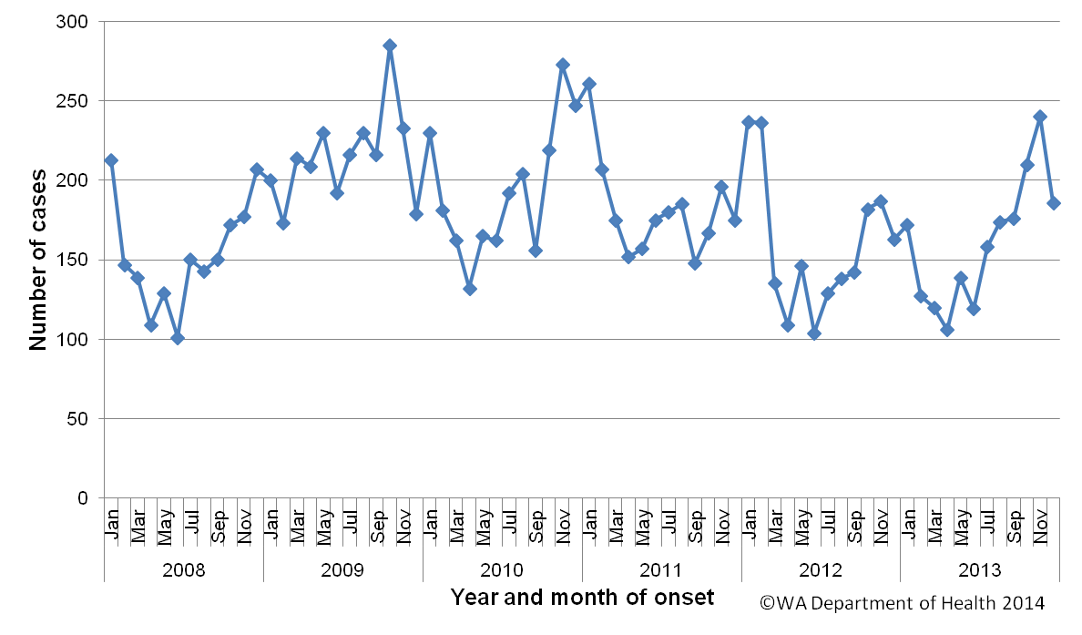
Figure 1. Number of cases of campylobacteriosis by year and month of onset, WA, 2008 to 2013.
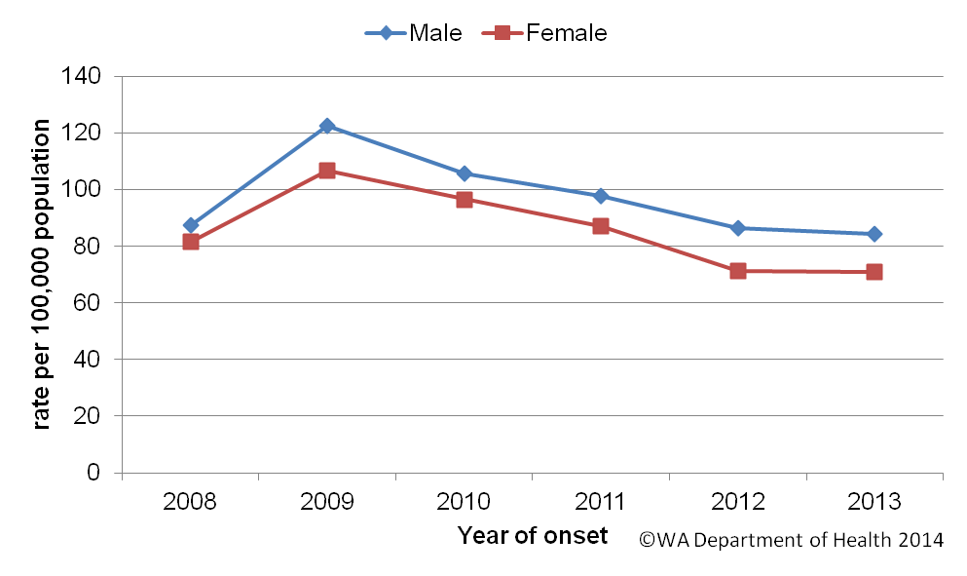
Figure 2. Campylobacteriosis notification rates by sex, WA, 2008 to 2013
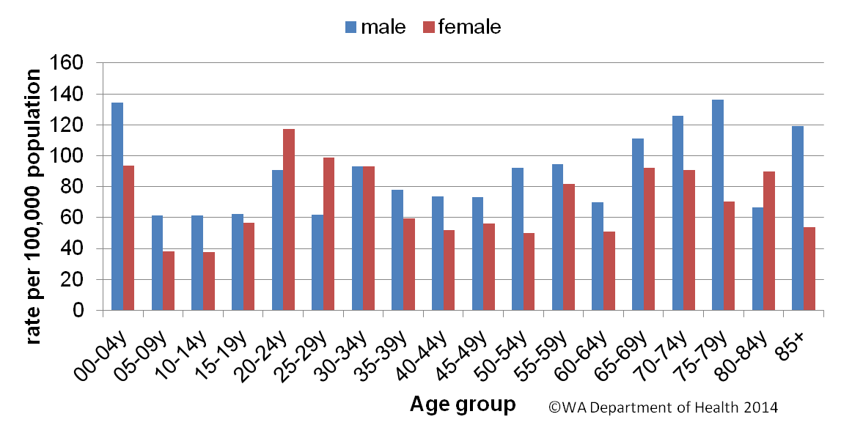
Figure 3: Age-specific notification rates for campylobacteriosis by sex, WA, 2013
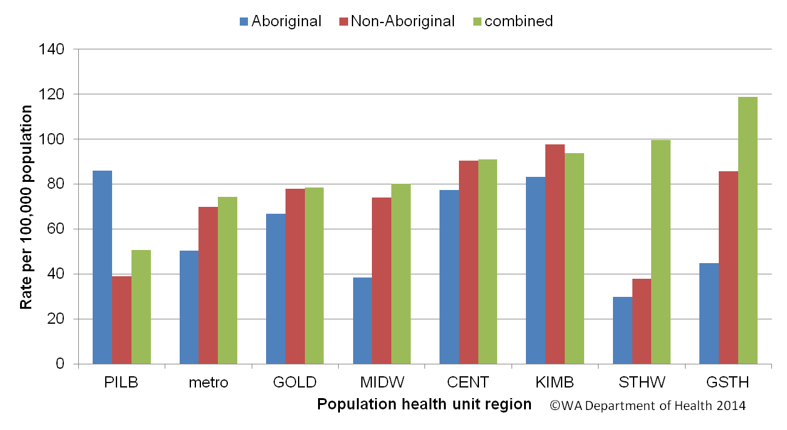
Figure 4. Campylobacteriosis notification rates by region and Aboriginality, WA, 2013

Salmonellosis
Salmonellosis, which is an infection due to Salmonella, was the second most commonly notified enteric infection in WA in 2013, with 1269 cases (Appendix 1). The salmonellosis notification rate for 2013 was 51.2 cases per 100 000 population which is a 7% increase on 2012 (48.1 cases per 100 000 population) and similar to the previous five year average (49.6 cases per 100 000 population). The number of salmonellosis notifications was generally highest in the summer months but peaked in April 2013 (Figure 5).
The overall notification rate for females (50.6 per 100 000 population) was 11% higher than the rate for males (45.6 per 100 000 population). As in previous years, the <1- 4 year age group had the highest notification rate (148 per 100 000 population) (Figure 6). The young adult age groups of 20 to 24 years, and 25 to 29 years, had the next highest notification rates (56 and 55 per 100 000 population, respectively).
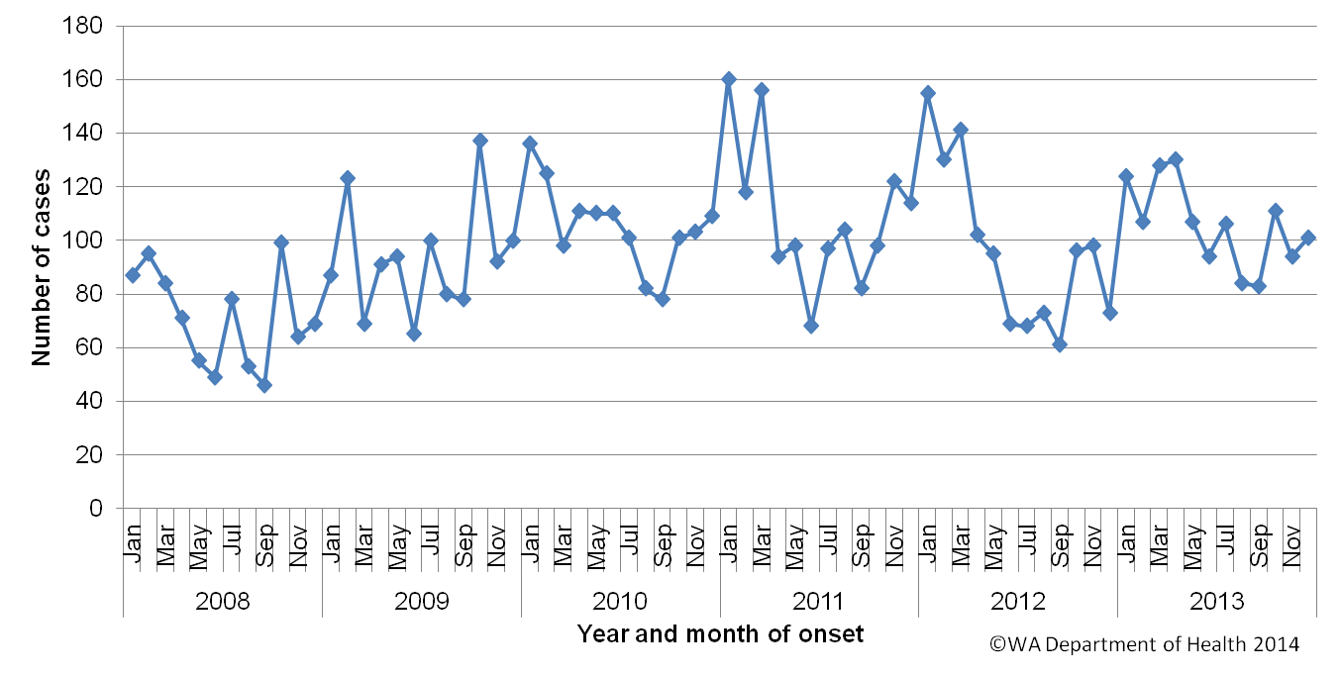
Figure 5. Number of cases of salmonellosis by year and month of onset, WA, 2008 to 2013

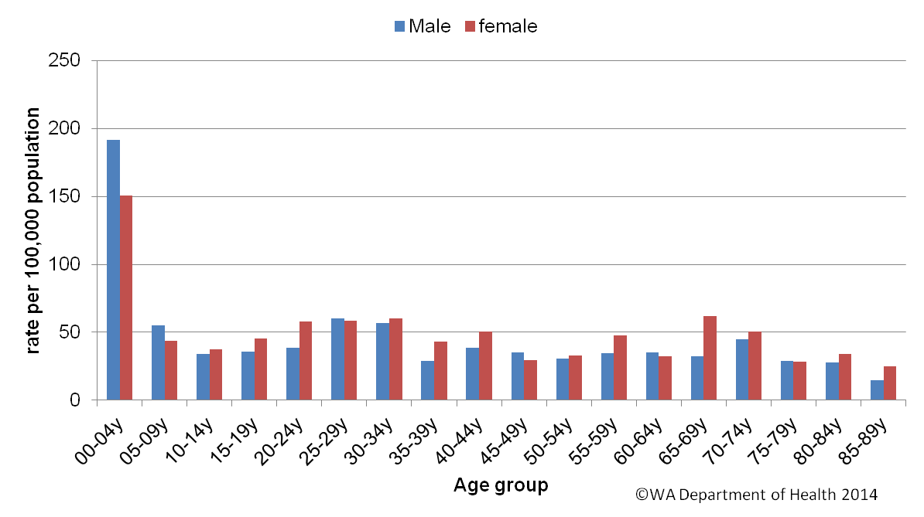
Figure 6. Age-specific notification rates for salmonellosis by sex, WA, 2013

The overall salmonellosis notification rate for Aboriginal people was 105 cases per 100 000 population, which was more than double the notification rate for non-Aboriginal people at 46 cases per 100 000 population.
The Kimberley region had the highest notification rate in 2013 (231 per 100 000 population) which was approximately five times the rate for the metropolitan region, which had the lowest notification rate at 45 cases per 100 000 population. In the Kimberley, rates were higher for both Aboriginal and non-Aboriginal people when compared with other regions (Figure 7).
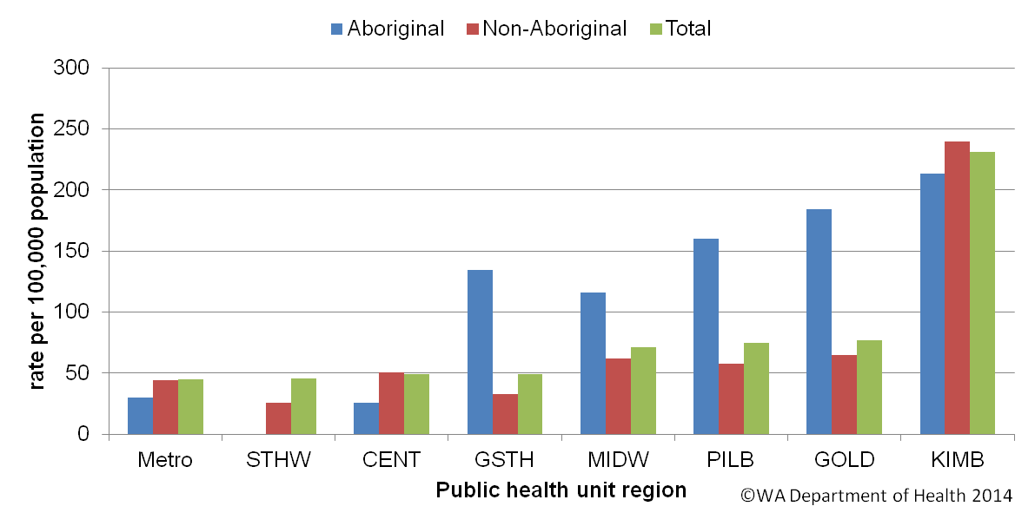

Figure 7. Salmonellosis notification rates by region and Aboriginality, WA, 2013

The most commonly notified Salmonella serotype in WA in 2013 was STM, with 347 notifications (Table 1), which was 18% higher than 2012 and the same as the mean of the previous five years. There were three foodborne outbreaks caused by STM (described in Section 5.1).
The second most commonly notified serotype was S. Enteritidis (SE) with 229 notifications. There was a steady increase in SE notifications from 2008 to 2010 which had 336 SE notifications, followed by progressive decreases in notifications (Figure 8). In 2013, 87% (199/229) of cases with S. Enteritidis infection travelled overseas during their incubation period and of these cases, 77% (n=153) had travelled to Indonesia. There were 21 (9%) cases of S. Enteritidis that appeared to be locally acquired and these were interviewed to determine possible risk factors for the cause of illness but no common source was identified.
Notifications for S. Paratyphi B var Java, S. Chester, S. Muenchen , S. Virchow, S. Newport, and S. Weltevreden were substantially higher in 2013 compared to the five year mean. Most cases of S. Paratyphi B var Java, S. Newport and S. Weltevreden acquired their illness overseas and most reported travel to Indonesia. Most cases of S. Infantis, S. Chester, S. Muenchen and S. Virchow acquired their illness in Western Australia and there was one foodborne outbreak due to S. Infantis. Of those Salmonella cases with known travel history, the proportion of overseas acquired cases peaked in 2010 at 53%, and from 2011 to 2013, 42% to 44% of cases acquired their illness overseas (Figure 9).

Table 1. Number and proportion of the top 10 Salmonella serotypes notified in WA, 2013, with comparison to the 5-year average
*Percentage of total Salmonella cases notified in 2013
‡Ratio of the number of reported cases in 2013 compared to the five year mean of 2008-2012.

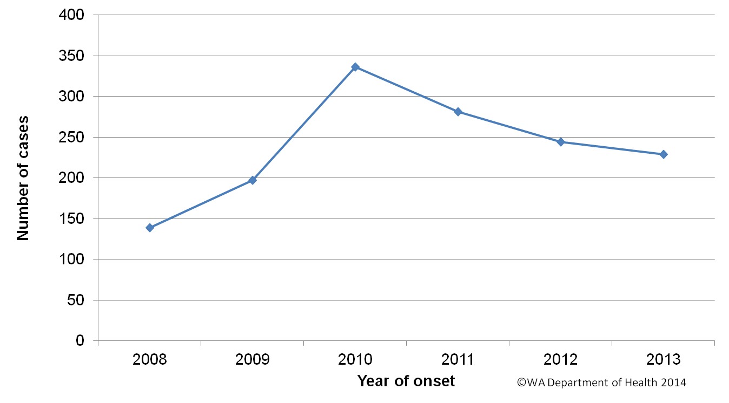
Figure 8. Number of cases of S. Enteritidis by year of onset, WA, 2008 to 2013

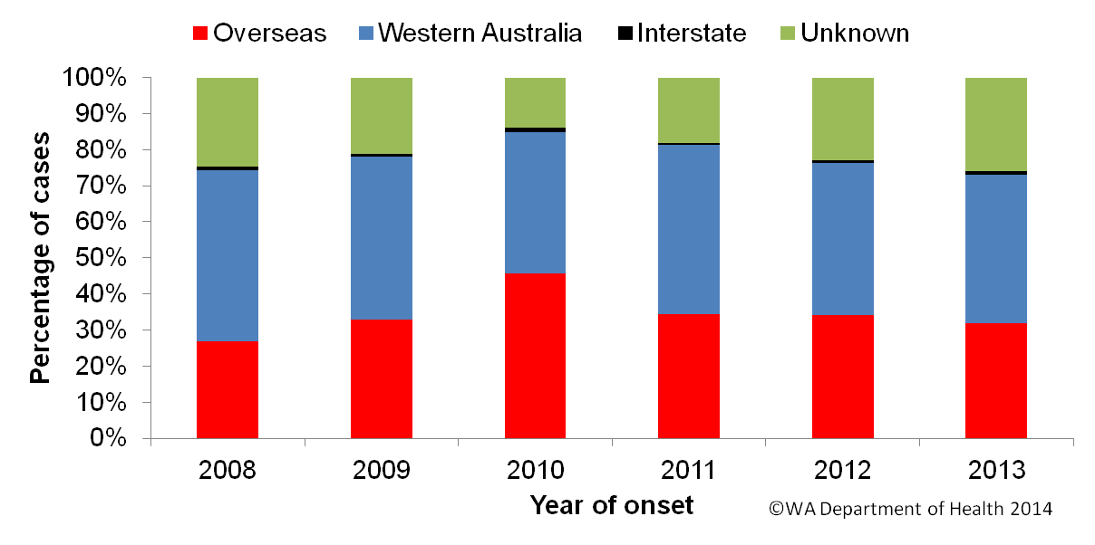
Figure 9. Proportion of salmonellosis cases acquired overseas, by year of onset, 2008 to 2013

Cryptosporidiosis
There were 372 cryptosporidiosis cases notified in 2013, which was the third most common notifiable enteric disease. The notification rate (15 cases per 100 000 population) was twice the rate of 2012, and 50% higher than the mean of the previous five years (10 cases per 100 000 population) (Appendix 1). In each of the years from 2008 to 2013 cryptosporidiosis case numbers were higher in the late summer through to autumn, (Figure 10).

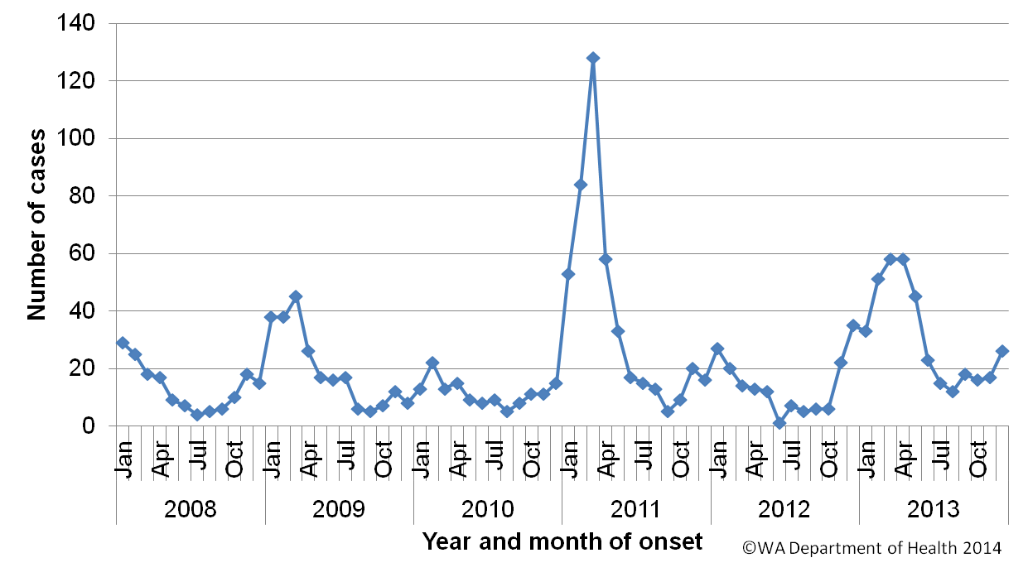
Figure 10. Number of cases of cryptosporidiosis by year and month of onset, WA, 2008 to 2013

The cryptosporidiosis notification rate was 16% higher in females than males in 2013 (13.8 and 16.3 per 100 000 population, respectively) (Figure 11). The <1- 4 years age group had the highest notification rate (84 per 100 000 population), and accounted for 38% of all cryptosporidiosis notifications. The overall notification rate for the Aboriginal population was 5.7 times the rate for the non-Aboriginal population (66.5 and 11.6 cases per 100 000 population, respectively) (Figure 12). The Kimberley region had the highest notification rate (150 cases per 100 000 population), and the metropolitan regions the lowest notification rates (11 cases per 100 000 population). Of those cryptosporidiosis cases with known place of acquisition, most (81%) people acquire their illness in WA with 18% of people acquiring their illness overseas.
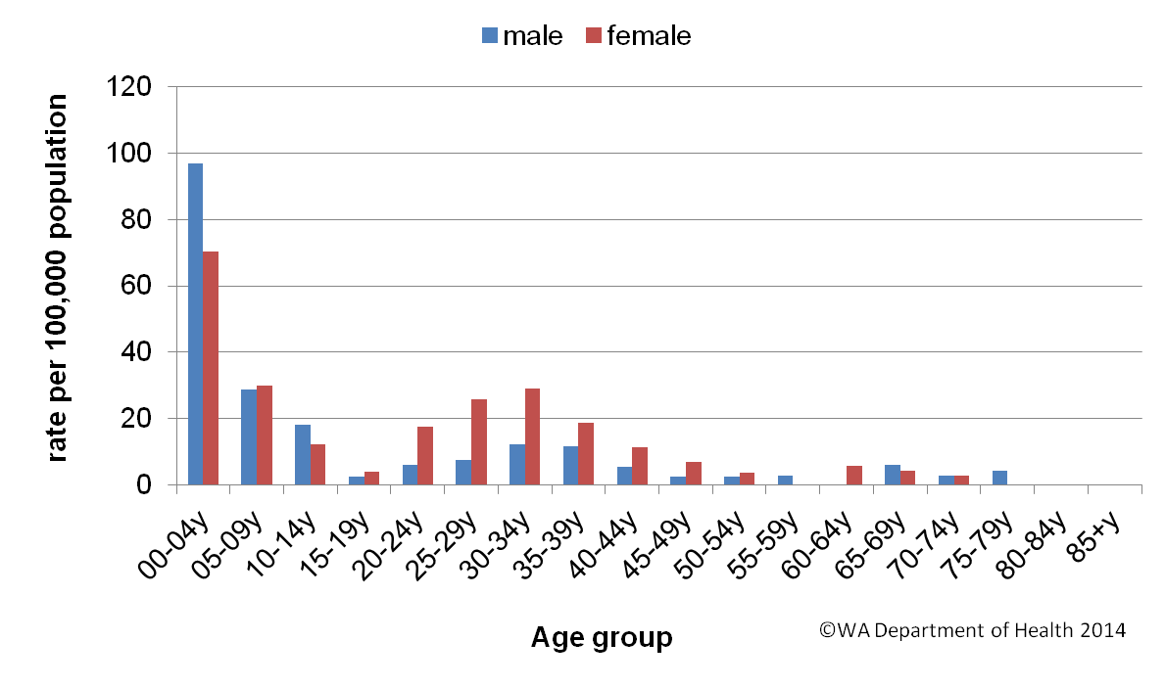
Figure 11. Age-specific notification rates for cryptosporidiosis by sex, WA, 2013
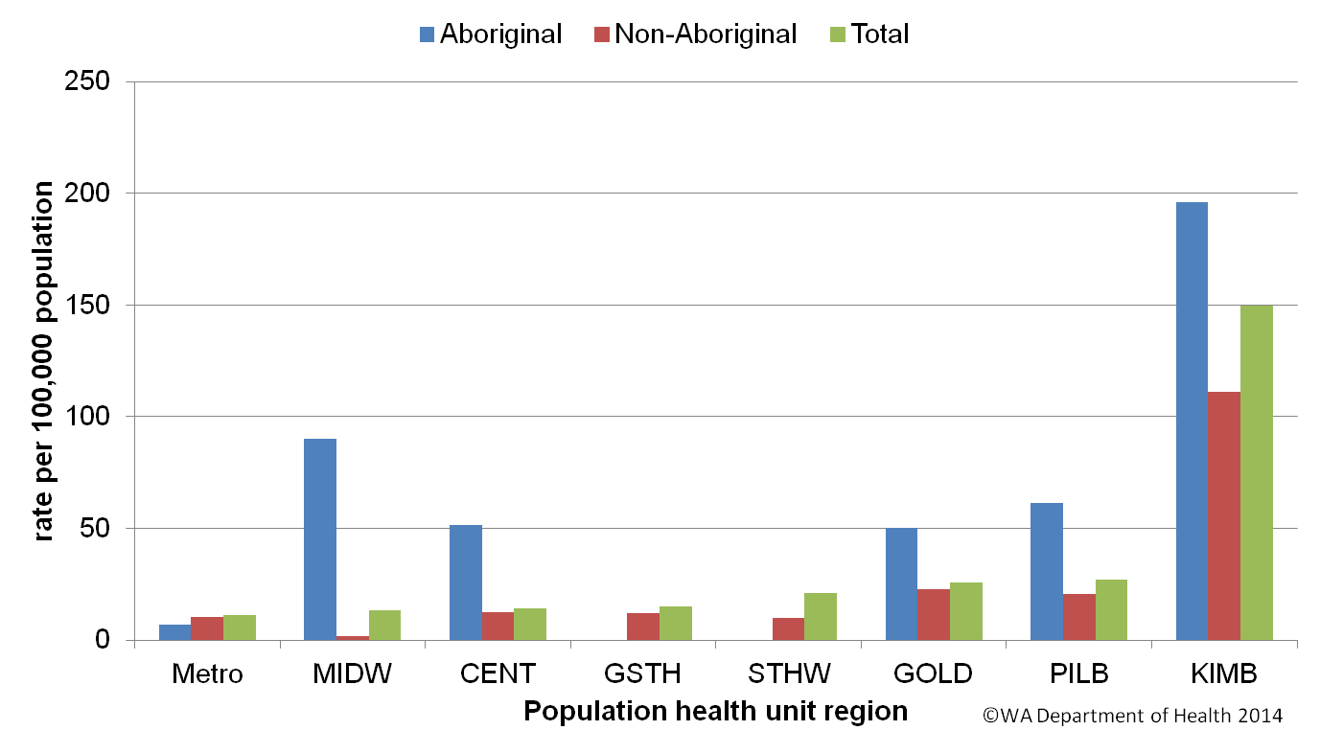
Figure 12. Cryptosporidiosis notification rates by region and Aboriginality, WA, 2013

Rotavirus infection
There were 346 cases of rotavirus infection in WA in 2013 (14 per 100 000 population), making rotavirus the fourth most commonly notified enteric infection. The notification rate in 2013 was similar to rate in 2012 (14.5 per 100 000 population), although 20% lower than the previous five year average of 17.5 cases per 100 000 population per year (Appendix 1). The increase in notifications in 2013 was due to a large increase in case numbers in the winter, which also occurred in 2012 (Figure 13). Of the 346 cases, 193 were genotyped (by Murdoch Childrens Research Institute, Victoria) and the most common types were G3P[8] (86/193: 45%), G2P[4] (34/193: 18%) and G1P[8] (23/193: 12%). In 2012 the most common typed was G12P[8] (90/192: 47%), G1P[8] (60/190: 31%) and G2P[4] (15/192: 8%).
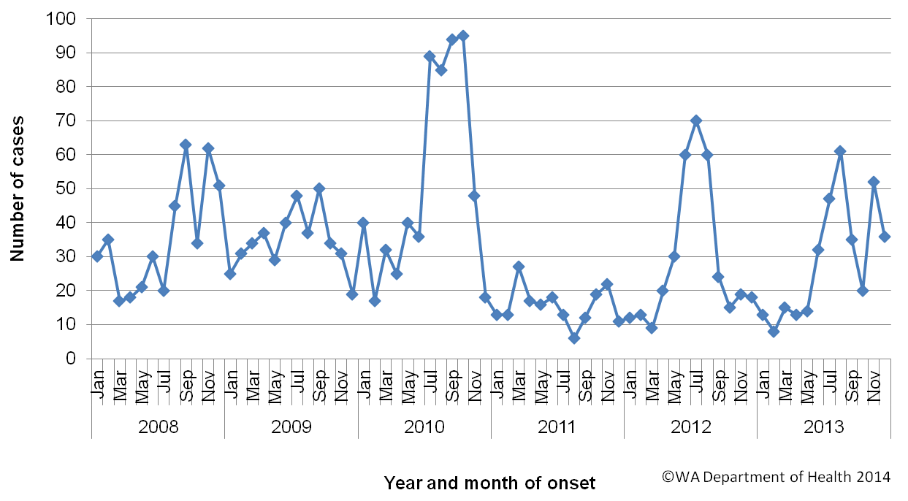
Figure 13. Number of cases of rotavirus infection by year and month of onset, WA, 2008 to 2013
As in previous years, the age group with the highest rotavirus notification rate in 2013 was the youngest age group, the <1- 4 years group (114 cases per 100 000 population), the age cohort for which vaccination was available, followed by the oldest age group, the 85+ years group (32 cases per 100 000 population) (Figure 14). The overall notification rate was similar for females and males (13.7 and 14.2 per 100 000 population, respectively).
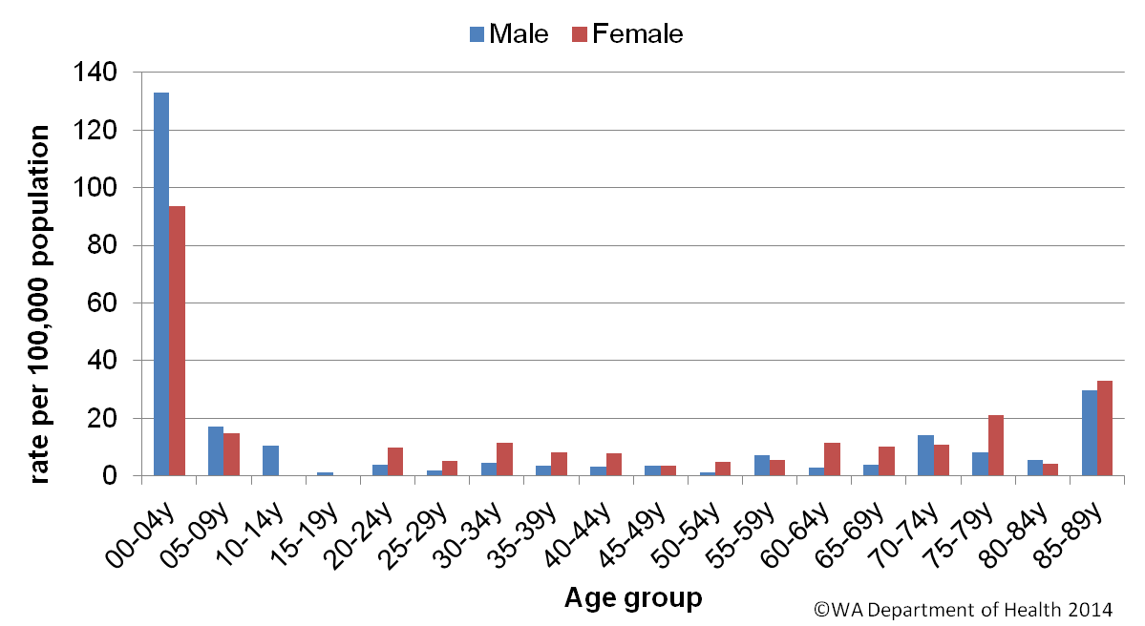
Figure 14. AAge-specific notification rates for rotavirus by sex, WA, 2013ge-specific
The regions with the highest rotavirus notification rates in 2013 were the Kimberley and Pilbara (109 and 48 cases per 100 000 population, respectively) (Figure 155). Overall notification rates were 6.3 times higher for Aboriginal than for non-Aboriginal people (69 and 11 per 100 000 population, respectively). Of those rotavirus cases with known place of acquisition, most (90%) people acquire their illness in WA with 9% of people acquiring their illness overseas.
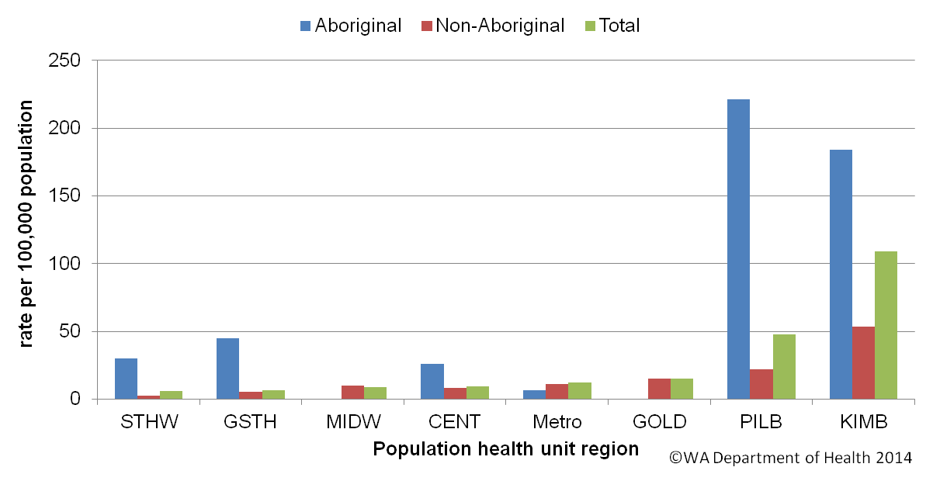
Figure 15. Rotavirus notification rates by region and Aboriginality, WA, 2013

Shigellosis infection
There were 69 shigellosis notifications in 2013, with a notification rate of 2.8 per 100 000 population, which was 30% higher than the previous year, and 41% lower than the previous five year average (Appendix 1). The lowest number of notifications was in the winter period followed by an increase in notifications from September to December (Figure 16).
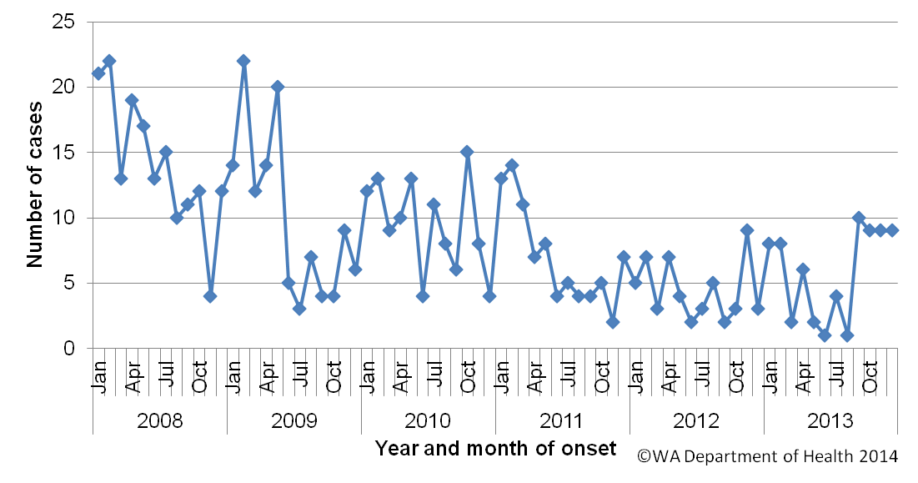
Figure 16. Number of cases of shigellosis by year and month of onset, WA, 2008 to 2013
The shigellosis notification rate was higher for females than for males in 2012 (2.9 and 2.6 per 100 000 population, respectively). The ≤4 year old age group had the highest rate with 7.7 cases per 100,000 population and the rate was similar among remaining age groups (Figure 17). The population health regions with the highest notification rates was the Kimberley (15 cases per 100 000 population) and Goldfields (10 cases per 100 000 population). There were no shigellosis cases notified in the Wheatbelt region of WA (Figure 18).
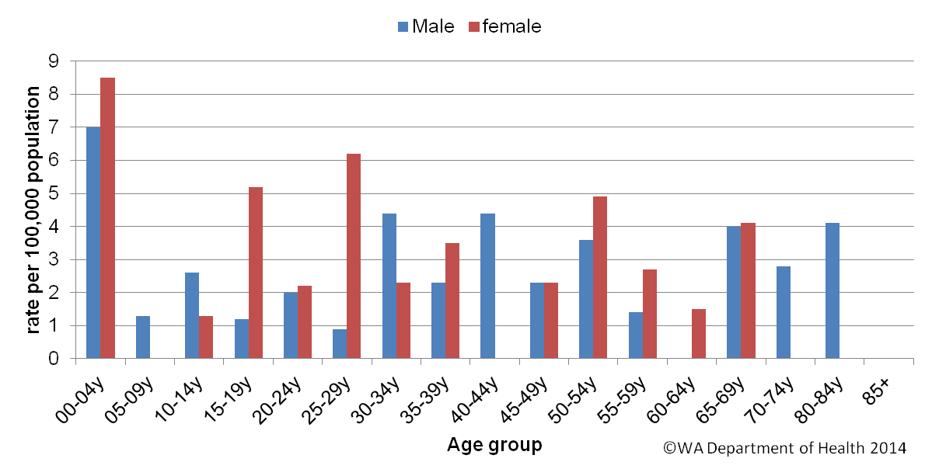
Figure 17. Age-specific notification rates for shigellosis by sex, WA, 2013
In 2013, the notification rate was 8.7 times higher for the Aboriginal population as compared to the non-Aboriginal population (19.2 and 2.2 per 100 000 population, respectively) (Figure 18). There was an 82% reduction in the number of shigellosis notifications for Aboriginal people from 2008 to 2013, and most of this reduction occurred in the remote regions of WA (Kimberley, Pilbara, Goldfields and MidWest) (Figure 19). This continued decrease in notifications in Aboriginal people has not been observed in non-Aboriginal people with 82 notifications in 2008 and from 2009-2013, notifications have ranged from 40-73. Most non-Aboriginal cases reside in metropolitan Perth.

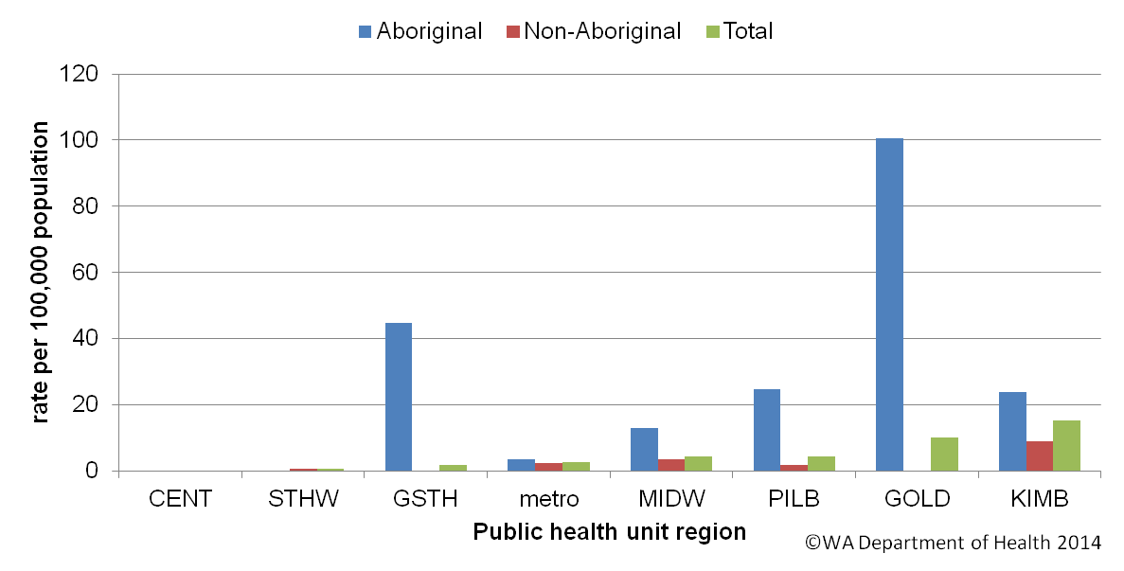
Figure 18. Shigellosis notification rates by region and Aboriginality, WA, 2013
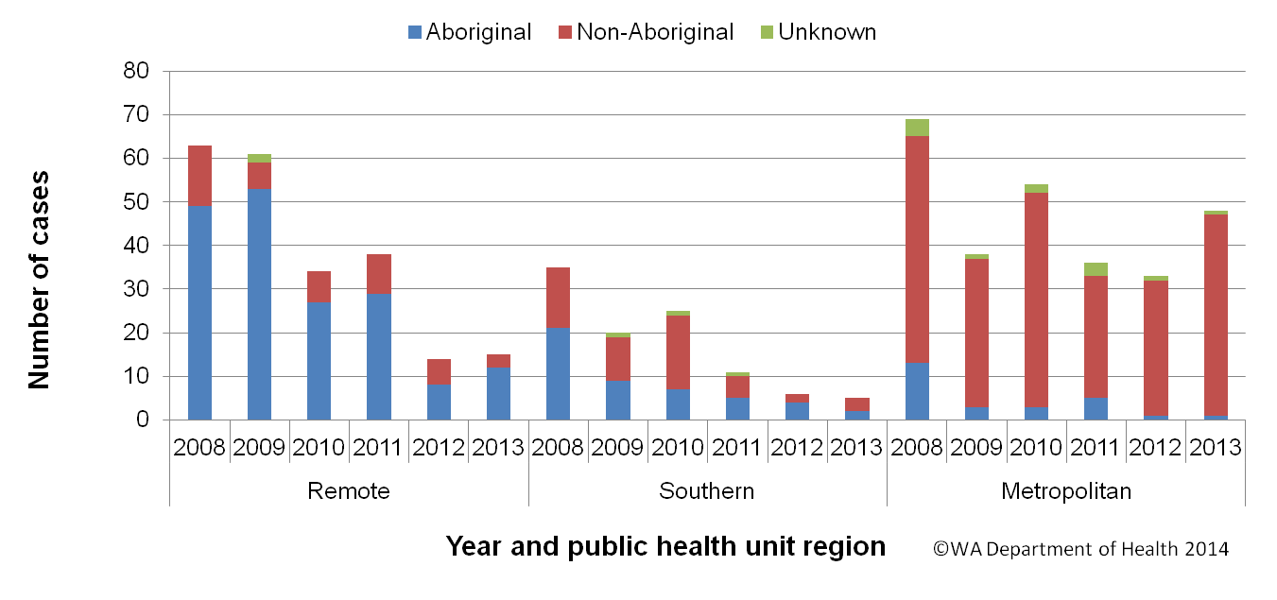
Figure 19. Year of onset and public health region of residence, for Aboriginal and non-Aboriginal shigellosis cases
The number of overseas acquired shigellosis cases remained relatively constant from 2008 to 2013, with the exception of 2010 when there was nearly double the number of overseas acquired cases notified compared to the other years (Figure 20). Of the remaining shigellosis notifications in 2013, there were 20 (29%) notifications were an isolate was either not cultured from a positive specimen or the isolate was not speciated and of these 20 notifications, 16 were detected by nucleic acid detection. Of the remaining shigellosis notifications in 2013, Shigella sonnei was the most common species (n=30, 60%). The most common S. sonnei biotype was biotype G, and most (66%) people with biotype G acquired their infection overseas. The second most common Shigella species was S. flexneri with 17 notifications (34%) and there was two notifications of S. boydii.
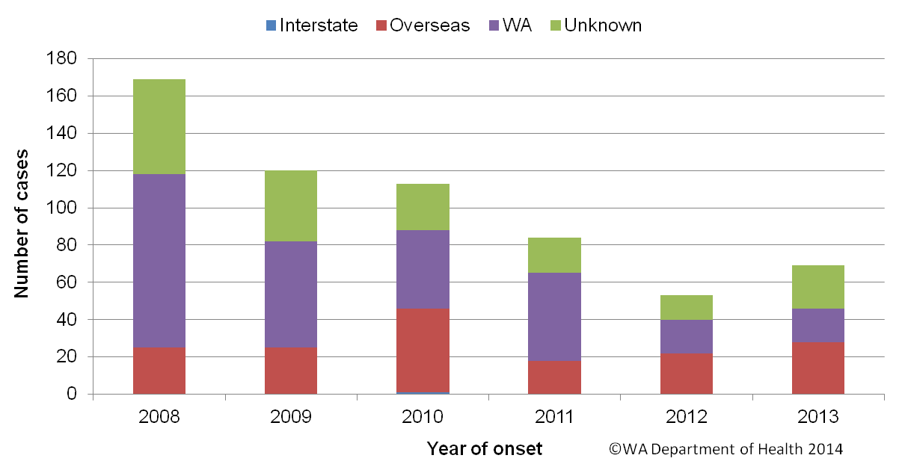
Figure 20. Place of acquisition for shigellosis cases, 2008 to 2013

Hepatitis A virus infection
There has been a marked reduction in the locally acquired hepatitis A cases in WA since 2009 (Figure 21). There were 14 cases of hepatitis A notified in 2013 with a rate of 0.6 cases per 100 000 population, which is the same as 2012, but a 41% reduction from the mean rate of the previous five years (1.0 per 100 000) (Appendix 1).
The age range for the 2013 cases was 8 to 55 years and a average age of 27 years, with 10 males and 4 female notifications. Most (10, 71%) notifications in 2013 were acquired overseas. Countries of acquisition were Indonesia (3 cases), Iraq (2 cases), Philippines (2 cases), and single cases who travelled to Thailand, East Timor, Ethiopia and Fiji. The three locally acquired cases were associated with the case who had travelled to Fiji with two cases acquiring their illness from drinking kava prepared by this case and the third case was a contact of one of these subsequent cases.
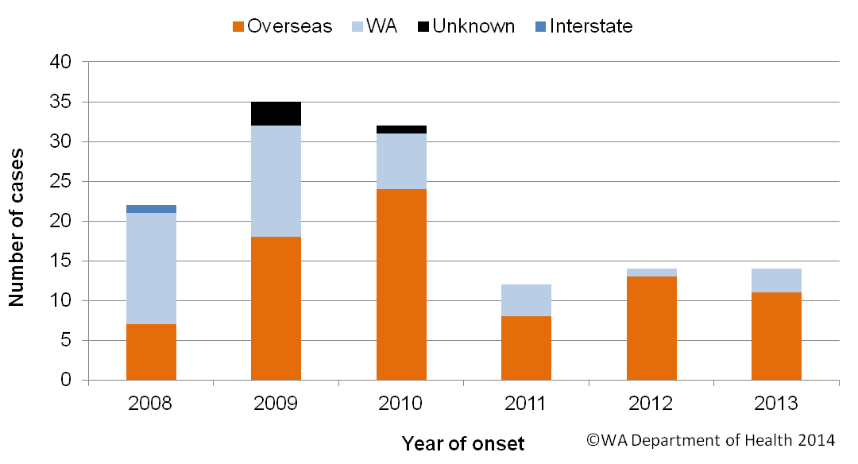
Figure 21. Place of acquistion for hepatitis A cases, 2008 to 2013

Typhoid and paratyphoid fever
In 2013, there were 10 reported cases of typhoid fever (caused by Salmonella Typhi) with a rate of 0.4 cases per 100,000 population which was a 28% decrease in the mean rate of the previous five years (Appendix 1). All cases had recently travelled overseas prior to illness and countries included India (n=6), Indonesia (n=3) and Pakistan (n=1). Ten cases of paratyphoid fever were notified in 2013 which included three cases of S. Paratyphi A (two PT 1, one PT2, one PT3, one PT13, one PT UNTY, one PT RDNC and three not phage typed). All cases had overseas acquisition and countries included India (n=4), Indonesia (n=2), Pakistan (n=2), Bangladesh (n=1) and Burma (n=1).

Listeriosis
There were eight cases of listeriosis due to Listeria monocytogenes infection notified in 2013 which is the same as the previous five year average of eight cases per year (Appendix 1). All cases were non-pregnancy related, 50% were females and ranged in age from 57 – 93 years (Figure 22). Five cases had immunocompromising illnesses, and two cases routinely took stomach acid lowering medication, the other one case was on methotraxate.
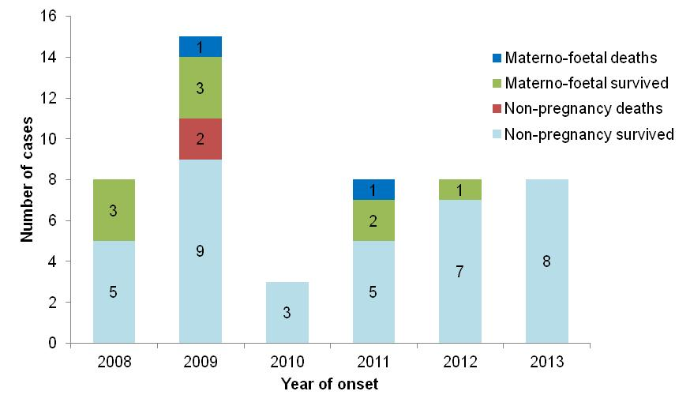
Figure 22. Notifications of listeriosis showing non-pregnancy related infections and deaths, and materno-foetal infections and deaths, WA, 2008 to 2013.

Vibrio parahaemolyticus infection
There were 15 cases of Vibrio parahaemolyticus infection in 2013 compared to the five year average of 11 cases per year. Of the 15 cases, 50% were male and the median age was 41 years (range 23-66 years). All cases acquired their infection overseas (Thailand [8], Indonesia [4], Mozambique [1], Sri Lanka [1], and Vietnam [1]).

Yersinia infection
There were 12 case of Yersinia enterocolitica infection notified in 2013, which is about four times higher than the previous five year mean of three cases per year. Of the 12 cases 50% were male, three cases were aged between <1 and 9 years, three cases between 10 and 19 years, and six cases between 20 and 79 years. Of the ten cases with known travel history, three cases had acquired the infection overseas (Indonesia) and seven cases in WA. Of the seven cases locally acquired, two cases were from the WA regional areas (Goldfields, and Great Southern) and five cases were from the Perth metropolitan area. In 2013, seven cases were diagnosed with Yersinia enterocolitica infection by nucleic acid detection only and five cases using culture. However, in the previous five years culture was the only method of case diagnosis of Yersinia enterocolitica infection.

STEC infection
In 2013, there were 4 cases of STEC notified, which is similar to the previous five year mean of five cases per year. Three cases had a phage type 0157 and one case had a phage type of 0517:H-. The four cases acquired the infection locally. Of the four cases, two cases resided in the Perth metropolitan area (under 10 years) and two resided in regional WA (one case was 34 years from the South West, and one case was 64 years from the Great Southern).

Hepatitis E
In 2013, there were four cases of hepatitis E notified, which is the same as the previous five year mean of four cases per year. Of the four non-Aboriginal cases, three resided in the Perth metropolitan area and one in the Kimberley region. There were three male cases and one female case. Three cases had acquired the infection overseas (two in India and one case in Indonesia) and one case in WA (residence of case in Perth metropolitan area).

Cholera, botulism and HUS
There were no cases of cholera, botulism or HUS notified in WA in 2013.

Gastrointestinal disease outbreaks and investigations

Foodborne/suspected foodborne outbreaks
There were 13 foodborne or suspected foodborne gastroenteritis outbreaks investigated in WA in 2013 (Table 2). The 13 foodborne outbreaks caused at least 185 WA cases and 19 hospitalisations. Short descriptions of these outbreaks are described in 2013 quarterly reports. In the previous five years (2008 to 2012) there was an average of 11 (range 4-17) foodborne or suspected foodborne outbreaks per year.
Aetiology
Of the 13 outbreaks, three outbreaks each were caused by unknown pathogens and Salmonella Typhimurium (STM PFGE 0011, 0151, 0039), two outbreaks by norovirus, and one outbreak each was caused by Clostridium perfringens, Salmonella Infantis, Listeria and hepatitis A. The clinical symptoms, duration of illness and incubation period of the three outbreaks with unknown aetiology indicated that they could have been due to norovirus. Illness characteristics in one outbreak suggested a toxin mediated cause by a pathogen such as C. perfringens or Bacillus cereus.
In the previous five years, Salmonella species caused most (n=22, 43%) outbreaks, followed by norovirus-like virus (n=13, 24%). Campylobacter species caused 2 outbreaks, Clostridium perfringens caused two outbreaks, Cyclospora species caused one outbreak and hepatitis A caused one outbreak. Thirteen outbreaks were caused by unknown pathogen but the illness of cases in these outbreaks suggested norovirus was the cause.
Food vehicles
The investigations of the 13 outbreaks identified food vehicles for six outbreaks. Salmonella Typhimurium (PFGE 0039) outbreak was associated with eggs (suspected) and Salmonella Infantis outbreak was associated with multiple foods including egg salad, Thai beef salad, seafood salad, fried rice, coleslaw, rice and salad. One outbreak each was associated with the following foods: Kava (hepatitis A); chicken curry (suspected toxin mediated); salad (norovirus); and duck pancakes (unknown pathogen).
In the previous five years there were 54 foodborne or suspected foodborne outbreaks and food vehicles were identified for 25 (46%) outbreaks. Of these 25 outbreaks, the most common implicated foods were dishes containing eggs in five outbreaks, chicken in five outbreaks, fresh produce in four outbreaks, nine outbreaks implicating a range of dishes, and multiple dishes in one outbreak. Of the 29 outbreaks with unknown food vehicles, the aetiological agents included Salmonella (n=10), norovirus (n=7), Campylobacter (n=7), Cyclospora (n=1) and Clostridium perfringens (n=1).

Epidemiological investigation and evidence
The evidence that supported that the 13 investigations of enteric outbreaks were due to foodborne or suspected foodborne transmission was obtained using analytical studies for five outbreaks and descriptive cases series (DCS) for eight outbreaks. The analytical studies involved interviewing those people who were at the meal using a questionnaire on all foods/drinks available. These studies can be used to find a statistical association between a food eaten and illness and in 2013 an association was found in one of the five outbreaks . For the remaing four outbreaks, there was still strong circumstantional evidence to support suspected foodborne transmission including ill food handlers (2 outbreaks) or ill people eating a common meal (2 outbreaks). The DCS involves interviewing ill people with an open ended questionnaire to identify a common foodbusiness and/or foods but also relies on other evidence such as testing suspected foods and determining if there are ill foodhandlers. Of the eight outbreaks investigated by DCS, the pathogen (S. Infantis) was detected in food in one outbreak. The strong circumstantial evidence for the remaining seven outbreaks included independently eating at common venue or sharing a common meal (5 outbreaks) or ill foodhandler(s) (2 outbreaks)
For the previous five years the evidence used to support that 54 outbreaks were due to foodborne transmission was obtained using analytical studies for 19 (35%) outbreaks and nine outbreaks found an association between illness and a food. Of the cases series for 33 (61%) outbreaks, the pathogen was identified in food for six outbreaks. No formal study was carried out for two outbreaks.
Food preparation settings
The setting where food was prepared for the 13 foodborne outbreaks in 2013, included six (36%) restaurants (caused by norovirus, STM PFGE type 0151 & 0039, and unknown aetiology), one aged care (caused by Clostridium perfringens), two commercial caterers (caused by Listeria and norovirus), two private residences (caused by hepatitis A and STM PFGE0011) one takeaway (caused by S. Infantis), and one at a school (suspect toxin mediated).
In the previous five years, the most common setting where food was prepared among the foodborne outbreaks was restaurants (n=24, 44%), followed by commercial caterers (n=7, 13%), aged care (n=5, 9%), takeaway (n=4, 7%), private residence (n=2, 4%), bakery (n=2, 4%), camp (n=2, 4%), cruise (n=1, 2%), and military base (n=1, 2%).
Major factors for contamination of food
The major factors for the contamination of food for the 13 outbreaks in 2013 was person to food to person transmission (n=4), which both involved sick people handling food. These four outbreaks were due to norovirus (n=2), suspected norovirus-like pathogen (n=1) and hepatitis A (n=1). Contributing factors for the other outbreaks included food handling safety issues (n=1), inappropriate storage (no temperature controls) (n=1) and inadequate cleaning of equipment (n=1). No contamination factors could be identified for two outbreaks.
The major factors for contamination of food in the 54 outbreaks in the previous five years was also person to food to person transmission (n=12, 22%). Of these, eight outbreaks were due to norovirus. There were seven outbreaks where the contributing factor was cross-contamination of foods with raw ingredients and five of these outbreaks were due to Salmonella species. One outbreak was caused inadequate equipment cleaning (pathogen unknown). There were 34 outbreaks with no identified contributing factor.

Table 2 Foodborne and suspected foodborne outbreaks, 2013

¹Month of outbreak is the month the outbreak was first report or investigated, whichever is earliest
*PT = phage type, PFGE=pulsed field gel electrophoresis
# D = descriptive, M= microbiological, A=Analytical, DK=Don’t know

Outbreaks due to non-foodborne transmission or with an unknown mode of transmission
In 2013, there were 119 outbreaks of gastroenteritis investigated that were not classified at foodborne disease outbreaks. These outbreaks included 92 outbreaks associated with suspected person to person transmission, one outbreak each due to suspected waterborne transmission and animal to person transmission and 27 outbreaks were the mode of transmission was unclear or unknown (Figure 23).
Suspected person to person outbreaks
Of the 92 suspected as person to person (PTP) transmission, 65 (71%) occurred in residential care facilities, nine (10%) in child care centres, six (7%) each in hospitals and schools, three (3%) in camps, two at institutions (2%) and one (1%) on a bus tour (Table 3). The causative agent for 45 (49%) of the outbreaks was confirmed as norovirus and one (1%) outbreaks were due to rotavirus and norovirus. In the remaining outbreaks (40%) the causative agent was unknown, either because a pathogen was not identified during testing, specimens were not collected, or viral testing was not requested. A total of 2133 people were affected by these outbreaks, with 31 hospitalisations and 9 deaths.
The number of PTP outbreaks in 2013 was a 16% decrease on the number of outbreaks in 2012 (n=110), and 19% lower than the average of the previous five years (n=114). The long term season trend (2008 to 2013 data) for PTP outbreaks is that PTP outbreaks start to increase in August and peaking in December (Figure 24).
Outbreaks with unknown mode of transmission
In the remaining 27 outbreaks the likely mode of transmission was unclear or unknown, with 21 (78%) occurring in aged care facilities, two (7%) in hospitals and one each at a child care centre (4%), in a institution (4%), in a school (4%) and a private residence (4%) (Table 3). Below are descriptions of these outbreaks according to site of outbreak.
- There were 21 outbreaks in aged care facilities where the average percentage of cases with diarrhoea was 92% (range 83-100%) and average percentage of cases vomiting was 16% (range 0-33%). These symptoms are not norovirus-like and therefore described as unknown rather than person-to-person. Most of the outbreaks (16/21) had specimens tested which were negative for common bacterial and viral pathogens (including norovirus). Of the 16 outbreaks with specimens tested, seven outbreaks had specimens tested for Clostridium perfringens. Three outbreaks had 1-2 specimens positive for C. perfringens but results were inconclusive, as PFGE types were different for isolates of one outbreak, PFGE typing was not done for isolates of another outbreak and there was only one isolate for the third outbreak.
- There were two outbreaks in hospitals and one outbreak in an institution with 3 to 7 cases with gastroenteritis, were diarrhoea was the most common symptom and only one case in one outbreak vomited. These symptoms are not typical of norovirus. Specimens were tested for two of these outbreaks and specimens were negative for common bacterial and viral pathogens (including norovirus).
- There were was single gastroenteritis outbreaks in a childcare centre a school and a private residence but investigators were unable to obtain sufficient information to determine the possible mode of transmission for these outbreaks.

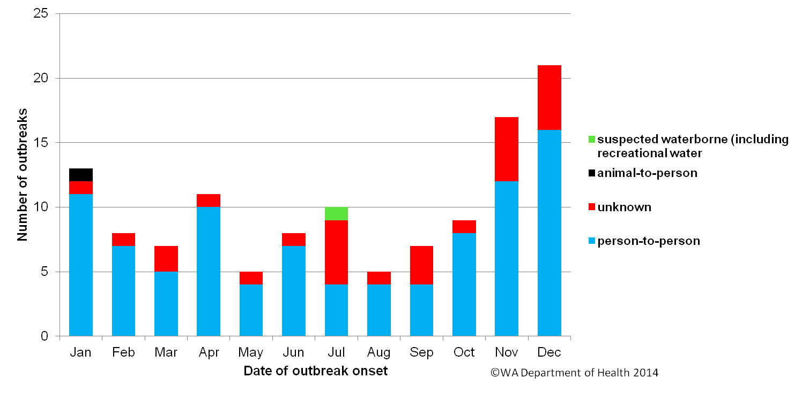
Figure 23. Number of gastroenteritis outbreaks designated as non-foodborne or with unknown mode of transmission reported in WA, in 2013
Table 3. Outbreaks due to non-foodborne transmission or unknown mode of transmission in WA by setting and agent, 2013

¹ Deaths temporally associated with gastroenteritis, but contribution to death not specified

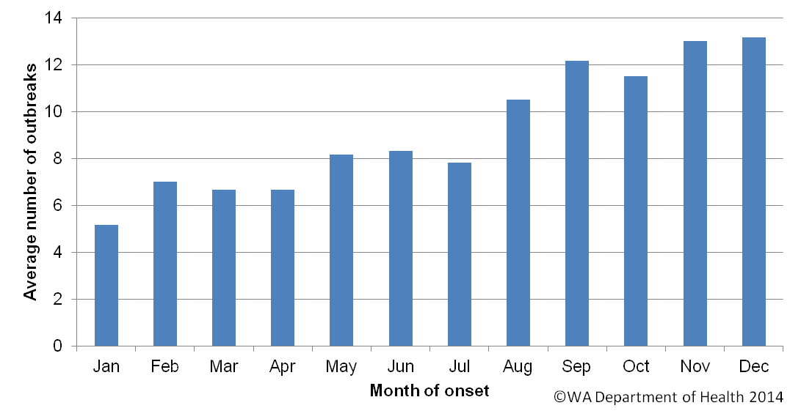
Figure 24. Average number of gastroenteritis outbreaks due to suspected person to person transmission for specific months for the period 2008 to 2013 in WA.

Cluster investigations
In 2013, there were nine Salmonella clusters and one Listeria cluster investigated (see Table 4) which are described in 2013 quarterly reports.
Significant clusters
Salmonella Typhimurium PFGE 121
There were seven cases of STM PFGE 121 (phage type 22) with onsets from April to June, compared to the five year average of one case. Six of the seven cases were aged 3 years or younger. Of the six young children, five cases had dogs that were fed raw kangaroo meat and the seventh case was a 53 year old male who had contact with a dog that was fed raw chicken necks and beef bones. Four retail samples of kangaroo meat for dogs and cats were sampled, all were positive for a variety of Salmonella serotypes, including S. Muenchen (in one sample), S. Orion (in two samples), S. Infantis (in one sample), S. Typhimurium (in one sample) and S. Newport (in one sample).
Salmonella Infantis
Clusters of Salmonella Infantis were investigated in the first (13 cases) and second quarters (16 cases) of 2013. S. Infantis was the fourth most common Salmonella serotype in 2013 with 55 cases and more than twice the number of cases than the five year historic average. Of the 29 cases, 16 had complete interviews and foods frequently eaten by these cases included eggs at home (88%), cucumber (75%), pasteurised milk (69%) and bananas (69%). S. Infantis isolates from cases were PFGE typed and there were 11 different PFGE types, including type 3 (n=11), type 2 (n=4), type 4 (n=3) and type 5 (n=3). The consumption of free range eggs was the hypothesis for the cause of illness and 11 S. Infantis isolates were cultured from eggs of four different producers. Seven of the 11 egg isolates had the same PFGE type as human cases (PFGE type 2 [n=4], PFGE type 4 [n=1], PFGE type 5 [n=2]). Environmental investigations determined that the four egg producers obtained their chickens from the same hatchery. The descriptive epidemiological and microbiological evidence, although not definitive, indicates that eggs contaminated with S. Infantis were the likely source of many of the human cases. No specific intervention was carried out on farms and notifications of S. Infantis cases decreased from an average of 7 cases/month from January to May to average of 3 cases/month for June to December 2013.
Listeria
In December 2012, three cases with the same Listeria type (serotype 1/2, binary type 82, PFGE type 8H:110A:2T) were investigated. Another Listeria case with the same molecular type was notified in the 1st quarter of 2013. All cases were female with ages 57 (n=2), 75 and 58 years of age, with onsets 23/2/12, 19/11/12 and 24/11/12 and 25/2/2013. During their exposure period three of the four cases had eaten yoghurt, rockmelon, watermelon, strawberries, bagged salad and brie/camembert. There was also a case notified in a 55 year old Victoria (ID 320120628962) with the same molecular type in and a collection date 27/3/2012. No food history was obtained from this case. No hypothesis for the cause of illness was established for this cluster.

Table 4. Cluster investigations in WA by month investigation started, setting and agent, 2013
* PFGE=pulsed field gel electrophoresis

OzFoodNet WA research projects

Cryptosporidium project
A case-control study of sporadic Cryptosporidium cases was started in June 2010 to determine risk factors for infection. The recruitment of participants has been completed with 204 cases and 612 controls enrolled. Molecular typing of Cryptosporidium positive specimens is also being conducted by Murdoch University. The data will now be analysed and published in peer-review journals.

Review of Guidelines for the management of gastroenteritis outbreaks in residential care facilities
In Dec 2010 a review of the “Guidelines for the Management of Gastroenteritis Outbreaks in Residential Care Facilities” was undertaken including widespread consultation with stakeholders. As a result of this consultation a 2nd edition of the guidelines was produced, and circulated to aged care facilities and stakeholders in 2013.

Joint co-ordination of national case series study of Salmonella Typhimurium PT 193
In 2009 a large increase in the number of notifications of STM PT 193 was observed nationally. This increase was predominantly seen with isolates of STM PT 193 that were resistant to ampicillin, streptomycin, tetracycline and sulphonamide (ASTSu). Increases in STM PT 193 and monophasic Salmonella PT 193 were also noted in the northern hemisphere, where the increase appears to be linked to pork consumption. A national cluster investigation was commenced in September 2011 and involved interviewing cases of STM PT 193 and monophasic Salmonella PT 193 with ASTSu with a questionnaire focussing on consumption of pork and beef products. A total of 85 cases were recruited, and 49 cases met the inclusion criteria and exposures of these cases were analysed. Food consumption in cases was compared to historical Salmonella case food frequency databases in WA and Hunter, NSW, but no strong hypothesis for the possible cause of the increase in these Salmonella types was determined at the national or jurisdictional level. It was recommended that jurisdictions continue to investigate clusters of STM PT 193, find out more information on non-human sources of STM PT 193 and increase sampling of meat, eggs and pet food products.

National descriptive study of Salmonella Enteritidis

Salmonella Enteritidis is globally important as it can infect the internal contents of eggs, and causes a large burden of illness in countries where this Salmonella is endemic in egg laying flocks. Surveillance to date shows that S. Enteritidis is not endemic in Australian chickens. However, S. Enteritidis is the second most commonly notified Salmonella in Australia with the majority of cases acquiring their infection overseas. The aim of the project is to describe the epidemiology of the recent increase in S. Enteritidis notifications in Australia. This will help inform public policy regarding prevention and control measures for S. Enteritidis infection. Data collection from jurisdictions was complete in February 2014 and analysis will occur in the first half of 2014.

References
- Hall G, Kirk MD, Becker N, Gregory JE, Unicomb L, Millard G, et al. Estimating foodborne gastroenteritis, Australia. Emerg Infect Dis 2005;11(8):1257-1264.
- OzFoodNet Working Group. A health network to enhance the surveillance of foodborne diseases in Australia. Department of Health and Ageing 2013. www.ozfoodnet.gov.au/internet/ozfoodnet/publishing.nsf/Content/Home-1 [14/03/2012]
- Western Australian Department of Health. A-Z list of case definitions. Western Australian Department of Health 2013. www.public.health.wa.gov.au/2/243/3/infectious_diseases_az_for_health_professionals.pm [14/3/2012]
- National notifiable disease surveillance system. National case definitions. Department of Health and Ageing 2013. www.health.gov.au/internet/main/publishing.nsf/content/cda_surveil-nndss-dislist.htm [14/03/2012]
- Western Australian Department of Health. Contact details for regional population / public health units. Western Australian Department of Health 2013. http://www.public.health.wa.gov.au/3/280/2/contact_details_for_regional_population__public_he.pm [05/04/3012].

Appendix 1: Number of notifications, notification rate and ratio of current to historical mean by pathogen/condition, 2008 to 2013, WA
¹Abbreviations: STEC: Shiga-toxin producing E. coli; HUS: Haemolytic Uraemic Syndrome. Rate is cases per 100 000 population. Mean of rates between 2008 and 2012.
This document can be made available in alternative formats on request for a person with a disability.

© Department of Health 2014

