
OzFoodNet
Enhancing Foodborne Disease Surveillance Across Australia

Government of Western Australia
Department of Health
Public Health and Clinical Services
Communicable Disease Control Directorate
Foodborne Disease Surveillance and Outbreak Investigations in Western Australia 2012
Acknowledgments

Acknowledgement is given to the following people for their assistance with the activities described in this report: Mr Brian MacKenzie, Ms Lyn O’Reilly, Ms Jenny Green, Mr Ray Mogyorosy and the staff from the enteric, PCR and food laboratories at PathWest Laboratory Medicine WA; Mr Bill Calder, Ms Belinda Loftus, Ms Anna Pardini and other staff from the FU of the Department of Health, Western Australia; Public Health Nurses from the metropolitan and regional Population Health Units; and Local Government Environmental Health Officer.

Contributors/Editors

Barry Combs, Nevada Pingault and Robyn Gibbs

Communicable Disease Control Directorate
Department of Health, Western Australia
PO Box 8172
Perth Business Centre
Western Australia 6849

Email: OzfoodnetWA@health.wa.gov.au

Telephone: (08) 9388 4999

Facsimile: (08) 9388 4877

Web:
OzFoodNet WA Health www.public.health.wa.gov.au/3/605/2/ozfoodnet_enteric_infections_reports.pm
OzFoodNet Department of Health and Ageing
www.ozfoodnet.gov.au/

Disclaimer:

Every endeavour has been made to ensure that the information provided in this document was accurate at the time of writing. However, infectious disease notification data are continuously updated and subject to change.

PUBLISHED BY
This publication has been produced by the Department of Health, Western Australia.

Executive summary and recommendations
This report is a summary of enteric disease surveillance activities and outbreak investigations in Western Australia (WA) in 2012.
Enteric disease causes a large burden of illness in the WA community. In WA, there are 16 enteric infections that are notifiable to the Department of Health. In addition, norovirus which is not notifiable, causes a large number of outbreaks mainly in residential care facilities. The Department of Health through OzFoodNet (OFN) and other agencies conducts surveillance and investigates outbreaks so that targeted interventions can be used to help prevent further transmission.
In WA, there was 3706 enteric disease notifications in 2012 with a rate of 157cases per 100 000 population which is 19% lower than the average for the previous five years. The age group with the highest rate was <1-4 years with a rate of 450 cases per 100 000 population. Aboriginal people have a rate 72% higher than non-Aboriginal people and the Kimberley region has a rate nearly 3 times higher than any other region. Of the notified enteric infections, 46% reported acquisition in WA, 21% reported overseas travel and 33% had unknown place of acquisition.
Describing results:
Rates are helpful when comparing groups with different population sizes (i.e different time periods, gender, race).
Incidence of specific enteric diseases
Campylobacteriosis was the most commonly notified enteric disease in 2012, comprising 51% of enteric notifications. Salmonellosis (31% of total) and rotavirus (10% of total) infections were the 2nd and 3rd most commonly notified enteric infections, respectively.
The notification rate for campylobacteriosis and salmonellosis for 2012 was lower by 15% and 14% respectively compared to the mean of the previous five years. The decrease in the notification rate for salmonellosis was largely attributable to a decrease in the notifications of Salmonella Typhimurium (STM), which were mostly WA acquired. Rates for cryptosporidiosis, shigellosis, rotavirus and hepatitis A infection were lower in 2012 than the mean of the previous five years. The notification rate for typhoid fever (n=18) and paratyphoid fever (n=9) in 2012 was 64% and 36% higher respectively than the mean of the previous five years. Almost all of the typhoid and paratyphoid fever infections were acquired overseas.
Notification rates were highest in the <1 - 4 year age group for all of the major enteric infections, with the exception of shigellosis. For most of the enteric infections, notification rates were higher for Aboriginal people as compared to non-Aboriginal people. The greatest difference was for shigellosis, with the notification rate for Aboriginal people 10 times the rate for non-Aboriginal people. The rural regions had the highest notification rates for most of the enteric diseases, for both Aboriginal and non-Aboriginal people, with the Kimberley having the highest rates of salmonellosis, cryptosporidioisis, shigellosis and rotavirus infection.
Foodborne and suspected foodborne outbreaks
In 2012, there were 14 outbreaks of foodborne or suspected foodborne disease investigated in WA that caused at least 229 cases of illness. Four of these outbreaks were caused by Salmonella species, two by norovirus, one each by Listeria and Campylobacter and for six outbreaks the infectious agent or toxin was unknown. The largest foodborne outbreak in 2012, was due to STM pulsed field gel electrophoresis type (PFGE) 0039 with 128 cases notified. Most people infected had consumed chicken prior to illness and chicken meat samples were positive for the same type of Salmonella. The Department of Health Food Unit (FU) worked with the chicken meat producers who carried out interventions to reduce the contamination of chicken meat.
Of the 14 outbreaks, there were 10 outbreaks were a food was implicated which included a range of foods such as raw almonds, sandwiches, chicken, cheese and liver pate. Among outbreaks in the previous five years when a food was implicated, dishes containing eggs (10/22) were the most common food vehicle. The evidence used to implicate a food among the 10 outbreaks in 2012 included identifying the pathogen in the food (n=3), analytical studies (n=4) and strong descriptive evidence (n=3). The most common food preparation setting was restaurants (n=4), bakeries (n=2) and commercial caterers (n=2). Restaurants (25/51) were also the most common food preparation setting among outbreaks in the previous five years. The most common factor for the contamination of food in the 14 outbreaks was food handler contamination (n=4) followed by person to food to person transmission (n=2).
To help with environmental investigations of foodborne outbreaks, OFN and the FU collaborated to complete the “Guidelines for the environmental health investigation of a foodborne disease outbreak”.
Non foodborne enteric disease outbreaks
Non-foodborne enteric disease outbreaks are major cause of illness especially in institutions such as residential care facilities (RCF). There were 113 non-foodborne outbreaks reported in 2012 which was a 45% increase compared to 2011. The 113 outbreaks resulted in 3065 ill people, 67 hospitalisations and 14 deaths. Most of these outbreaks were due to person to person transmission (99%) in RCF (71%). The most common causative agent was norovirus (68%).
To help improve the management of gastroenteritis outbreaks in RCFs, OFN has recently completed a review of the “Guidelines for the management of gastroenteritis outbreaks in residential care facilities” and the second version will be published in 2013. The current guidelines can be found at the WA Public Health website.

Recommendations:
It is recommended that OFN WA:
- Continue to improve methods for surveillance and investigation of enteric disease.
- Continue the investigation of outbreaks to help prevent ongoing transmission of enteric pathogens.
- Continue to monitor long term trends into the causes of outbreaks.
- Conduct research into the causes and costs of enteric disease.
- Publish and distribute results of outbreak investigations, long term trends and enteric disease research.
- Engage with stakeholders to:
- Improve the integration of enteric disease surveillance between food animals, food and humans.
- Inform policy making in food safety to help reduce the burden of enteric disease.
- Table of contents
Executive summary and recommendations - 3 -
Table of contents - 6 -
List of Tables - 8 -
List of Figures - 8 -
1. Introduction - 9 -
2. Data sources and methods - 11 -
3.1. Data sources - 11 -
2.2. Data changes - 12 -
2.3. Data Collection by Aboriginality - 12 -
2.4. Regional Boundaries - 12 -
2.5. Calculation of rates - 13 -
2.6. Definitions: - 13 -
3. Site activities including prevention measures during the year - 13 -
3.1. Surveillance and investigation - 13 -
3.2. Conference meetings and presentations - 14 -
3.3. Joint authors on publications - 15 -
3.4. Membership of national OzFoodNet working groups - 15 -
3.5. Projects - 16 -
3.6. Policy Documents - 16 -
3.7. Other activities - 16 -
4. Incidence of specific enteric diseases - 16 -
4.1. Campylobacteriosis - 17 -
4.2. Salmonellosis - 19 -
4.3. Rotavirus infection - 24 -
4.4. Cryptosporidiosis - 27 -
4.5. Shigellosis infection - 29 -
4.6. Hepatitis A virus infection - 32 -
4.7. Typhoid and Paratyphoid fever - 32 -
4.8. Listeriosis - 33 -
4.9. Vibrio parahaemolyticus infection - 33 -
4.10. Yersinia infection - 34 -
4.11. Cholera, Botulism, STEC and HUS - 34 -
5. Gastrointestinal disease outbreaks and investigations - 34 -
5.1. Foodborne/suspected foodborne outbreaks - 34 -
5.2. Outbreaks due to non-foodborne transmission or with an unknown mode of transmission -40-
5.3. Cluster investigations -44-
6. OzFoodNet WA research projects -45-
6.1. Cryptosporidium project -45-
6.2. Review of Guidelines for the Management of Gastroenteritis Outbreaks in Residential Care Facilities -45-
6.3. Joint co-ordination of national case series study of Salmonella Typhimurium phage type 193 -46-
7. References -47-
Appendix 1: Number of notifications, notification rate and ratio of current to historical mean by pathogen/condition, 2007 to 2012, WA -48-

List of Tables
Table 1. Number and proportion of the top 10 Salmonella serotypes notified in WA, 2012, with comparison to 5-year average - 23 -
Table 2. Foodborne and suspected foodborne outbreaks, 2012 -39-
Table 3. Outbreaks of non-foodborne transmission or unknown mode of transmission in WA by setting and agent, 2012 -42-
Table 4. Cluster investigations in WA by month investigation started, setting and agent, 2012 -45-

List of Figures
Figure 1. Number of cases of campylobacteriosis by year and month of onset, WA, 2007 to 2012. Number of cases of campylobacteriosis by year and month of onset, WA, 2007 to 2012 - 18 -
Figure 2. Campylobacteriosis notification rates by sex, WA, 2007 to 2012 - 18 -
Figure 3. Age-specific notification rates for campylobacteriosis by sex, WA, 2012 - 19 -
Figure 4. Campylobacteriosis notification rates by region and Aboriginality, WA, 2012 - 19 -
Figure 5. Number of cases of salmonellosis by year and month of onset, WA, 2007 to 2012 - 20 -
Figure 6. Age-specific notification rates for salmonellosis by sex, WA, 2012 - 21 -
Figure 7. Salmonellosis notification rates by region and Aboriginality, WA, 2011 - 22 -
Figure 8. Number of cases of S. Enteritidis by year of onset, WA, 2007 to 2012 - 24 -
Figure 9. Proportion of salmonellosis cases acquired overseas, by year of onset, 2007 to 2012 - 24 -
Figure 10. Number of cases of rotavirus infection by year and month of onset, WA, 2007 to 2012 - 25 -
Figure 11. Number of notifications by month in 2012, for children in the 0 to 4 age group, and for other ages - 25 -
Figure 12. Rotavirus genotypes by month, 2012 - 26 -
Figure 13. A Age-specific notification rates for rotavirus by sex, WA, 2012ge-specific notification rates for rotavirus by sex, WA, 2012 - 26 -
Figure 14. Rotavirus notification rates by region and Aboriginality, WA, 2012 - 27 -
Figure 15. Number of cases of cryptosporidiosis by year and month of onset, WA, 2007 to 2012 - 28 -
Figure 16. Age-specific notification rates for cryptosporidiosis by sex, WA, 2012 - 28 -
Figure 17. Cryptosporidiosis notification rates by region and Aboriginality, WA, 2012 - 29 -
Figure 18. Number of cases of shigellosis by year and month of onset, WA, 2007 to 2012 ..- 29 -
Figure 19. Age-specific notification rates for shigellosis by sex, WA, 2012 - 30 -
Figure 20. Shigellosis notification rates by region and Aboriginality, WA, 2012 - 31 -
Figure 21. Year of onset and public health region of residence, for Aboriginal and non-Aboriginal shigellosis cases - 31 -
Figure 22. Place of acquisition for shigellosis cases, 2007 to 2012 - 31 -
Figure 23. Place of acquistion for hepatitis A cases, 2007 to 2012 - 32 -
Figure 24. Notifications of listeriosis showing non-pregnancy related infections and deaths, and materno-foetal infections and deaths, WA, 2007 to 2012. - 33 -
Figure 25. Year and month of onset for STM PFGE type 39 cases, 2010 to 2012 - 38 -
Figure 26 . Number of gastroenteritis outbreaks designated as non-foodborne or with unknown mode of transmission reported in WA, 2007 to 2012 -43-

Introduction
It has been estimated that there are 5.4 million cases of foodborne illness in Australia each year and that the cost of this illness is estimated at $1.2 billion per year¹. This is likely to be an underestimate of the cost of enteric illness in Australia as not all enteric infections are caused by foodborne transmission. Other modes of transmission are also very important causes of enteric infection including person to person, animal to person and waterborne transmission. Importantly, most of these infections are preventable through interventions at the level of primary production, commercial food handling, households and institution infection control.
This report describes Western Australian enteric disease surveillance and investigations carried out in 2012 by OzFoodNet WA (OFN) and other Western Australian Department of Health agencies. Most of the data presented in this report is derived from enteric disease notifications from doctors and laboratories received by the Department of Health, WA (WA Health) and are likely to underestimate the true incidence of disease. This data nevertheless remain the most important information on incidence of these infections for surveillance purposes in WA. In addition, norovirus which is not notifiable, is the cause of a large burden of illness in RCF and also in the general community.
OFN is part of the Communicable Disease Control Directorate (CDCD) of WA Health. OFN in Western Australia is also part of a National OFN network funded by the Commonwealth Department of Health and Ageing ². The mission of OFN is to enhance surveillance of foodborne illness in Australia and to conduct applied research into associated risk factors. The OFN site based in Perth is responsible for the whole of WA, which has a total population of approximately 2.4 million. Three epidemiologists sharing two full time positions co-ordinate activities in WA, which are overseen by a coordinating national epidemiologist in Canberra. Collaboration between states and territories is facilitated by circulation of fortnightly jurisdictional enteric surveillance reports, monthly teleconferences, tri-annual face-to-face meetings and through the informal network. This network also includes communication and consultation with Food Standards Australia New Zealand, the Commonwealth Department of Health and Ageing, the National Centre for Epidemiology and Population Health, the Communicable Diseases Network of Australia (CDNA) and the Public Health Laboratory Network.
The primary objectives of OFN nationally are to:
- estimate the incidence and cost of foodborne illness in Australia,
- investigate the epidemiology of foodborne diseases, by enhancing surveillance and conducting special studies on foodborne pathogens,
- collaborate nationally to coordinate investigations into foodborne disease outbreaks, particularly those that cross State, Territory and country borders,
- train people to investigate foodborne illness.
On a local level, OFN WA conducts surveillance of enteric infections to identify clusters and outbreaks of specific diseases and conducts epidemiological investigations to help determine the cause of outbreaks. OFN WA also conducts research into the risk factors for sporadic cases of enteric diseases and develops policies and guidelines related to enteric disease surveillance, investigation and control. OFN WA regularly liaises with staff from the Population Health Units (PHUs), the Food Unit (FU) in the Environmental Health Directorate of WA Health; and the Food Hygiene, Diagnostic and Molecular Epidemiology laboratories at PathWest Laboratory Medicine WA.
CDCD maintains and coordinates the WA notifiable disease surveillance system (WANIDD) and provides specialist clinical, public health and epidemiological advice to all PHUs. The WA notifiable diseases surveillance system relies on the mandatory reporting by doctors and laboratories for the surveillance of 16 notifiable enteric diseases and syndromes.
PHUs are responsible for public health activities, including communicable disease control, in their WA administrative health regions. There are 9 PHUs in WA: North Metropolitan, South Metropolitan, Kimberley, Pilbara, Midwest and Gascoyne, Wheatbelt, Goldfields, SouthWest, and Great Southern. The PHUs monitor RCF gastroenteritis outbreaks and provide infection control advice. The PHUs also conduct follow up of single cases of important enteric diseases including typhoid, paratyphoid, hepatitis A and E, cholera and Shigella dysenteriae. OFN will also assist with the investigation of these enteric diseases if there is a cluster and/or they are locally acquired, and will investigate RCF outbreaks if they are suspected to be foodborne.
The FU liaises with Local Government (LG) Environmental Health Officers (EHO) during the investigation of food businesses, and coordinates food business investigations when multiple LGs are involved.
The Food Hygiene, Diagnostic and Molecular Epidemiology laboratories at PathWest Laboratory Medicine WA provide public health laboratory services for the surveillance and investigation of enteric disease.

Data sources and methods

Data sources
Data on WA cases of notifiable enteric diseases were obtained from WANIDD. The notifications contained in WANIDD are received from medical practitioners and pathology laboratories under the provisions of the Health Act 1911 and subsequent amendments, and are retained in WANIDD if WA (for diseases not nationally notifiable) ³ or National case definitions are met ⁴.
Notifiable enteric diseases included in this report are campylobacteriosis, salmonellosis, rotavirus infection, cryptosporidiosis, shigellosis, hepatitis A infection, listeriosis, typhoid fever, shiga-toxin producing E. coli (STEC) infection, Vibrio parahaemolyticus infection, yersiniosis, hepatitis E infection, paratyphoid fever, cholera, haemolytic uraemic syndrome (HUS) and botulism. In March 2013, data for these diseases were extracted from WANIDD by optimal date of onset (ODOO) for the time period 01/01/2007 to 31/12/2012, and exported to Microsoft® Excel 2007. The ODOO is a composite of the ‘true’ date of onset provided by the notifying doctor or obtained during case follow-up, the date of specimen collection for laboratory notified cases, and when neither of these dates is available, the date of notification by the doctor or laboratory, or the date of receipt of notification, whichever is earliest.
Notification data extracted for this report may have been revised since the time of extraction. Subsequent minor changes to the data would not substantially affect the overall trends and patterns.
Information on Salmonella serotypes and Shigella species was obtained from PathWest Laboratory Medicine WA, the reference laboratory for Salmonella isolates in WA. Phage typing, multi-locus variable-number-tandem-repeat analysis (MLVA) and other specialised diagnostic data were obtained from the Microbiological Diagnostic Unit (MDU), University of Melbourne; the Australian Salmonella Reference Laboratory, Institute of Medical and Veterinary Science (Adelaide); and the National Enteric Pathogens Surveillance Scheme. Pulsed field gel electrophoresis (PFGE) typing was carried out at PathWest Laboratory Medicine WA.
Information on RCF outbreaks was collected by PHU nurses who forward collated epidemiological and laboratory data to OFN.

Data changes
Several changes in notification and testing practices need to be considered in interpreting data for the time period covered by this report. Notification data prior to 1 January 2009 includes cases that were diagnosed in WA but had a home address in another Australian jurisdiction, but excluded cases that were diagnosed in another jurisdiction but had a home address in WA. Notification data after 1 January 2009 includes cases that had a home address in WA but were diagnosed in another jurisdiction, but excludes cases diagnosed in WA with a home address in another jurisdiction.

Data Collection by Aboriginality
For the purposes of this report, the term ‘Aboriginal’ is used in preference to ‘Aboriginal and Torres Strait Islander’ to recognise that Aboriginal people are the original inhabitants of WA.
In WA, there is considerable mobility of Aboriginal people, both within WA and across the Northern Territory and South Australia borders, which means that some Aboriginal people will be patients of more than one health service. Due to the small size of the Aboriginal population in WA (3.1% of the total population in 2012) and the large number of cases reported in Aboriginal people, inaccuracies in the population estimates of Aboriginal people can have a disproportionate impact on calculated rates. In the preparation of this report, these factors are acknowledged as limitations. Information on Aboriginality is also missing in many instances.

Regional Boundaries
Notification data are broken down by regions that are based on PHU boundaries, reflecting WA Health administrative regions. PHU contact numbers and details are outlined at the website location in reference 5.

Calculation of rates
WA’s estimated resident population figures used for calculation of rates were obtained from Rates Calculator version 9.5.5 (WA Health, Government of Western Australia). The Rates Calculator provides population estimates by age, sex, Aboriginality, year and area of residence, and is based on population figures derived from the 2011 census. The estimated population for WA in 2012 was 2 417 945 persons. Rates calculated for this report have not been adjusted for age.

Definitions:
Foodborne outbreak is an incident where two or more persons experience a similar illness after consuming a common food or meal and epidemiological analyses implicate the meal or food as the source of illness.
Suspected foodborne outbreak is an incident where two or more persons experience a similar illness after consuming a common food or meal and a specific meal or food is suspected, but another mode of transmission cannot be ruled out.
Person to person outbreak is an incident where two or more persons experience a similar illness after exposure to an infected person.
Unknown outbreak transmission is an incident where two or more persons experience a similar illness but the mode of transmission is unable to be determined.

Site activities including prevention measures during the year
During 2012 the following activities and prevention measures were conducted at the WA OFN site.

Surveillance and investigation
- Ongoing surveillance of infectious enteric disease in WA.
- Investigation of seven local foodborne outbreaks, seven suspected foodborne outbreaks, five Salmonella clusters and one Listeria cluster.
- Participated in multi-jurisdictional outbreak investigations into
  - Salmonella Typhimurium (STM) phage type (PT) 3, PFGE type 434 (Sept-Nov)
  - Listeria (Sept).
- Investigation of eight Listeria monocytogenes cases.
- Surveillance of 18 typhoid and nine paratyphoid cases.
- Investigation of S. Enteritidis cases with unknown travel history and interviews of 19 locally acquired cases with a hypothesis generating questionnaire to identify risk factors for the cause of illness.
- Investigation of 113 non-foodborne gastroenteritis outbreaks, 79 of which occurred in RCFs, 22 in hospitals, six in child care centres, three in institutions and one each associated with a school, cruise ship and swimming pool. Investigation of 19 gastroenteritis outbreaks with unknown mode of transmission with 16 occurring at RCFs, and one each at an indoor play centre, camp and private residence.
- Ongoing monthly meetings with the Department of Health FU to improve foodborne disease surveillance and investigation in WA.
- Participation in monthly national OFN teleconferences.

Conference meetings and presentations
- Attended OFN face-to-face meetings in Brisbane in March, Adelaide in August and Newcastle in November, and gave the following presentations:
  - “MJOI of salmonellosis on an Australian cruise ship in PNG Waters” in Brisbane.
  - Co-chairing session on “Priorities/projects for OFN 2012-2015” in Brisbane.
  - “Salmonella Typhimurium 193 national cluster investigation” in Adelaide.
  - Reporting on the Communicable Disease Network Australia’s (CDNA) response to tabled paper “Options paper on surveillance for shiga toxin producing Escherichia coli (STEC) and haemolytic uraemic syndrome (HUS) in Australia” in Newcastle.
- Presentation for Public Health Nurses in May and November on ‘Update of gastrointestinal disease in WA’.
- Presented a summary of salmonellosis in WA to the National Salmonella Reference Network Meeting in Perth in October 2012.

Joint authors on publications
- Merritt, T. Combs, B, and N Pingault (2011) Campylobacter outbreaks associated with poultry liver dishes. Communicable Diseases Intelligence. 35(4):299-300.
- Vally, H. Hall, H. Dyda, A., Raupach, J. Knope, K. Combs, B and Desmarchelier, P. (2012). Epidemiology of Shiga toxin producing Escherichia coli in Australia, 2000-2010 BMC Public Health. 12:63.
- WA Department of Health OFN. WA Department of Health FU. (2012). Hotel foodborne outbreak. Food for thought. Issue 12. www.public.health.wa.gov.au/3/892/1/food_for_thought_newsletter.pm.
- Gibbs R, Nanyonjo R, Pingault N, Combs B, Mazzucchelli T, Armstrong P, Tarling G and Dowse G. (2011). An outbreak of Cyclospora infection on a cruise ship. Epidemiology and Infection. 139(12):1956-1964.
- Salmonella Typhimurium PFGE 436. Food for thought. Issue 14, October 2012. www.public.health.wa.gov.au/3/892/1/food_for_thought_newsletter.pm
- Function Centre Foodborne Outbreak. Food for thought. Issue 13, July 2012. www.public.health.wa.gov.au/3/892/1/food_for_thought_newsletter.pm
- Salmonella Typhimurium outbreak linked to chickens. Disease Watch. 16(2). 2012 http://www.health.wa.gov.au/diseasewatch/vol16_issue2/salmonella_typhimurium_outbreak_linked_to_chickens.cfm
- Almonds linked to Salmonella Typhimurium outbreak. Disease Watch. 16(5). 2012 www.health.wa.gov.au/diseasewatch/vol16_issue5/almonds.cfm

Membership of national OzFoodNet working groups
- Reviewing the Outbreak Register, a national database of foodborne disease outbreaks.
- Multi-jurisdictional outbreak investigation guidelines.
- Writing a paper titled “Options paper on surveillance for shiga toxin producing Escherichia coli (STEC) and haemolytic uraemic syndrome (HUS) in Australia” that was tabled and presented to CDNA.
- Review of egg outbreaks in Australia.

Projects (see section 6 for full description)
- Completed recruitment of cases and controls for Cryptosporidium Case Control study that started in the 2nd quarter of 2010.
- Joint co-ordination of national case series study of STM PT 193.

Policy Documents
- Worked with the FU in the
  - Development and completion of “Guidelines for the environmental health investigation of a food-borne disease outbreak”.
  - Updating of fact sheets on enteric diseases.
- Ongoing review of the WA “Guidelines for the management of gastroenteritis outbreaks in residential care facilities”.
- Completed draft of OFN WA operational guidelines.

Other activities
- Supervision of a UWA PhD student on a project examining the epidemiology of rotavirus in Western Australia.
- Collaborating with Murdoch University on the molecular epidemiology of Cryptosporidium.
- Attendance at a Risk Management, Compliance and Enforcement two day workshop facilitated by the FU.
- Assisting OFN Central in the development and maintenance of NetEpi databases.

Incidence of specific enteric diseases
In 2012, there were 3706 notifications of enteric disease in WA, which was an annual rate of 153 per 100 000 population. This rate was 19% lower than the mean rate for the previous five years of 194 per 100 000 population. The overall rate is heavily influenced by Campylobacter and Salmonella infections which comprise 51% and 31% of notifications, respectively. The age group with the highest rate was the <1-4 years with 450 cases per 100 000 and lowest rate was in the 10-14 year age group (89 cases per 100 000). Aboriginal people had a rate of 236 cases per 100 000 which was 72% higher than the rate in non-Aboriginal people (137 cases per 100 000). The age group with the highest rate among Aboriginal people was the <1-4 years with a rate of 1402 cases per 100000, compared to <1-4 year rate for non-Aboriginal people with 362 cases per 100000 population. The region with the highest rate was the Kimberley with 554 cases per 100 000 which was nearly three times higher than the Pilbara region which has the next highest rate (187 cases per 100 000). Aboriginal and non-Aboriginal people in the Kimberley had a similarly high rate.

Campylobacteriosis
Campylobacteriosis was the most commonly notified enteric infection in 2012 (1906 notifications, 78.8 per 100 000 population). This notification rate was 15% lower than for 2011, and 20% lower than the previous five years average (rates of 92.6 and 98.5 per 100 000 population, respectively) (Appendix 1 and Figure 1). In 2012, notifications decreased through the winter months, and this pattern was also seen for all but one of the previous five years. In 2012 the campylobacteriosis notification rate for males was higher than for females (87 and 71 per 100 000 population, respectively), which was also the case for the previous five years (Figure 2). The age group with the highest notification rate was the <1 - 4 years group (122 per 100 000 population) largely due to males in this age group having a rate of 152 per 100 000 population compared to females with a rate of 90. Notification rates were relatively similar across the remaining age groups compared to most other notifiable enteric infections, for which there are large differences between age groups (Figure 3).
The notification rate for non-Aboriginal people was over twice that for Aboriginal people (71 and 30 per 100 000 respectively) (Figure 4), which also differs from most other enteric infections, as generally notification rates are higher for Aboriginal people. The 2012 notification rate for campylobacteriosis was highest in the Kimberley region (138 per 100 000 population), mainly due to non-Aboriginal people in this region who have a rate of 169 per 100 000 population. The region with lowest the lowest rate was the Pilbara (44 per 100 000 population).

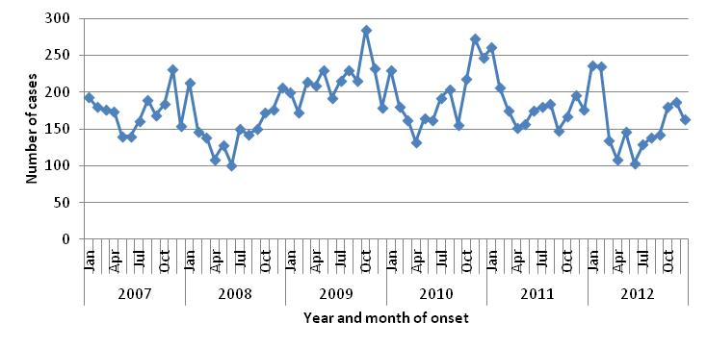
Figure 1. Number of cases of campylobacteriosis by year and month of onset, WA, 2007 to 2012.
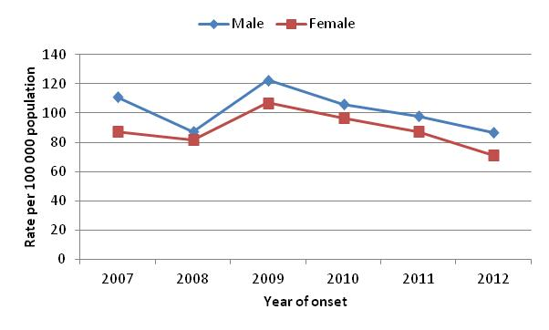
Figure 2. Campylobacteriosis notification rates by sex, WA, 2007 to 2012
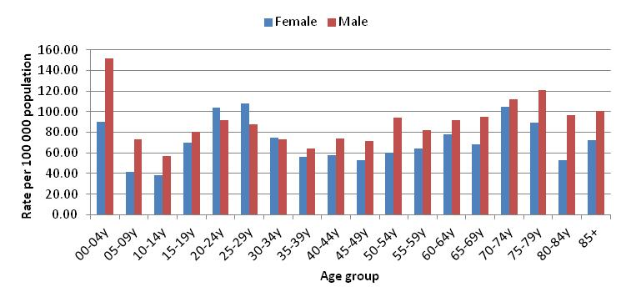
Figure 3: Age-specific notification rates for campylobacteriosis by sex, WA, 2012
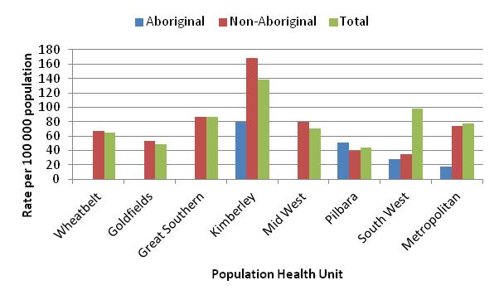
Figure 4. Campylobacteriosis notification rates by region and Aboriginality, WA, 2012

Salmonellosis
Salmonellosis, which is infection due to Salmonella, was the second most commonly notified enteric infection in WA in 2012, with 1162 cases (Appendix 1). The salmonellosis notification rate in 2012 (48.1 cases per 100 000 population), was 14% lower than 2011 (56.1 cases per 100 000) and similar to the previous five year average (49.4 cases per 100 000). The number of salmonellosis notifications was generally highest in the summer months) with a large peak in the 2011-2012 summer period (Figure 5).
The overall notification rate for females (50.6 per 100 000 population) was 11% higher than the rate for males (45.6 per 100 000). As in previous years, the <1- 4 year age group had the highest notification rate (148 per 100 000 population) (Figure 6). The young adult age groups of 20 to 24 years, and 25 to 29 years, had the next highest notification rates (56 and 55 per 100 000, respectively).
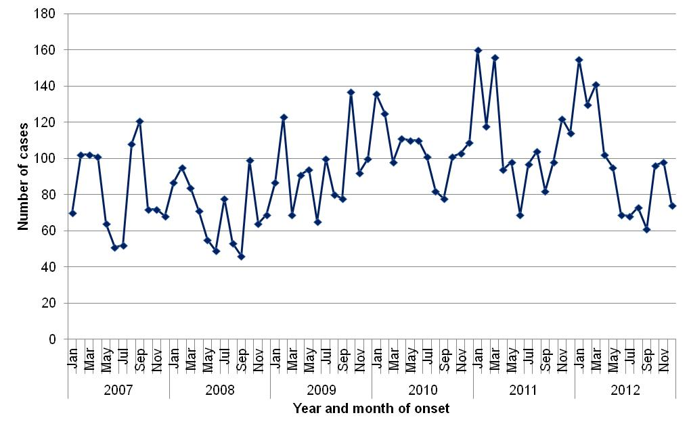
Figure 5. Number of cases of salmonellosis by year and month of onset, WA, 2007 to 2012

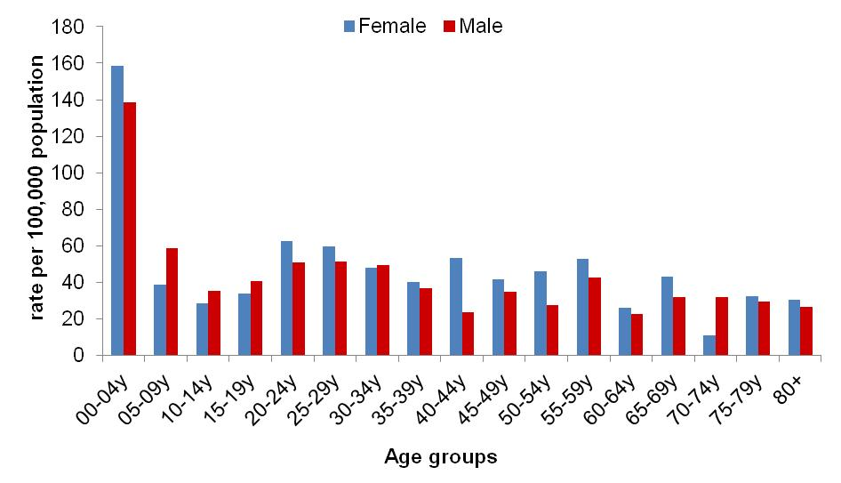
Figure 6. Age-specific notification rates for salmonellosis by sex, WA, 2012

The overall salmonellosis notification rate for Aboriginal people (89 per 100 000 population) was more than double the notification rate for non-Aboriginal people (43 per 100 000 population).
The Kimberley region had the highest notification rate in 2012 (196 per 100 000 population) which was approximately six times the rate for the Wheatbelt region, which had the lowest notification rate (33 cases per 100 000). In the Kimberley, rates were higher for both Aboriginal and non-Aboriginal people when compared with other regions (Figure 7).
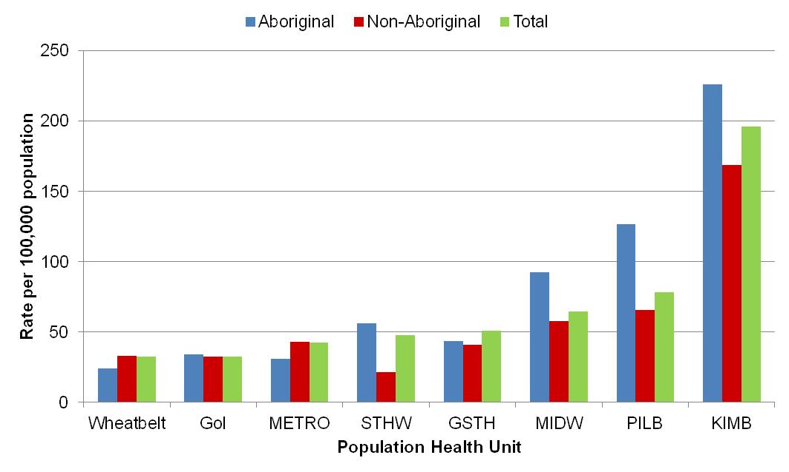
Figure 7. Salmonellosis notification rates by region and Aboriginality, WA, 2011

The most commonly notified Salmonella serotype in WA in 2011 was STM, with 296 notifications (Table 1), which was 31% less than 2011 and approximately 20% less than the mean of the previous five years. This decrease in STM was the major reason that overall Salmonella notifications in 2012 were 12% lower than 2011. There were two foodborne outbreaks caused by STM (described in Section 5.1).
The second most commonly notified serotype was S. Enteritidis (SE) with 244 notifications. There was a steady increase in SE notifications from 2007 to 2010, followed by annual decreases in 2011(16% decrease) and 2012 (13% decrease) (Figure 8). In 2012, most cases with S. Enteritidis infection (92%) travelled overseas during their incubation period and of these cases, 80% (n=181) had travelled to Indonesia, and most of these people had reported visiting Bali (66%, n=119). There were 16 (7%) cases of S. Enteritidis that appeared to be locally acquired and these were interviewed to determine possible risk factors for the cause of illness but no common source was identified.
Notifications for S. Paratyphi B var Java, S. Saintpaul, S. Infantis, S. Muenchen, S. Stanley, S. Kiambu and S. Weltevreden were also substantially higher in 2012 compared to the five year mean. Among cases of S. Paratyphi B var Java and S. Weltevreden that reported place of acquisition, the majority cases reported overseas travel, mostly to Indonesia. Most cases of S. Stanley were also acquired overseas but mainly from travel to Thailand. The proportion of overseas acquired Salmonella cases increased steadily between 2007 and 2010, with a decrease in 2011 and 2012 (Figure 9).

Table 1. Number and proportion of the top 10 Salmonella serotypes notified in WA, 2012, with comparison to the 5-year average
*Percentage of total Salmonella cases notified in 2012
‡Ratio of the number of reported cases in 2012 compared to the five year mean of 2007-2012.

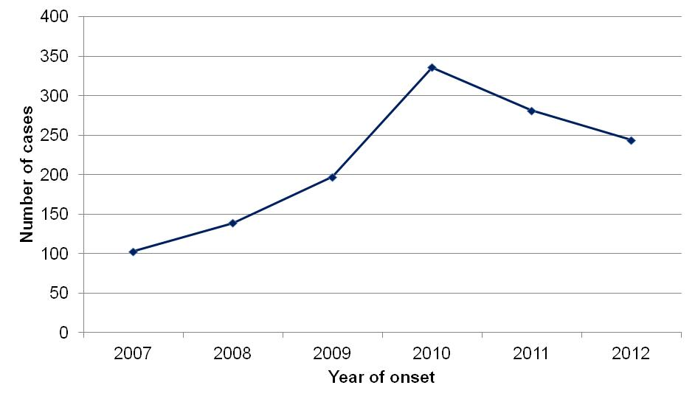
Figure 8. Number of cases of S. Enteritidis by year of onset, WA, 2007 to 2012

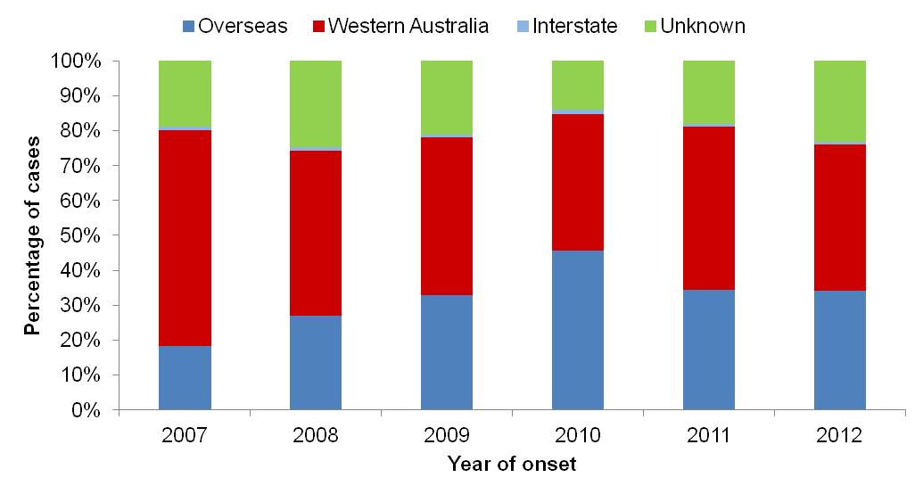
Figure 9. Proportion of salmonellosis cases acquired overseas, by year of onset, 2007 to 2012

Rotavirus infection
There were 350 cases of rotavirus infection in WA in 2012 (14.5 per 100 000 population), making rotavirus the third most commonly notified enteric infection. The notification rate in 2012 was nearly double that of the previous year, although lower than the previous five year average of 18 cases per 100 000 population per year (Appendix 1). The increase in notifications in 2012 was due to a large increase in case numbers in the winter, which also occurred in 2007 and 2010 (Figure 10). In 2012 the number of notifications increased for both children aged <1- 4 years (the age cohort for which vaccination was available) and older people (Figure 11). Genotyping results were available up to June 2012, and suggest that the increase in case numbers in the winter months was due to increased infections with genotypes G12P[8] and G1P[8](Figure 12). Genotype G12P[8] has emerged globally in recent years⁶.
. 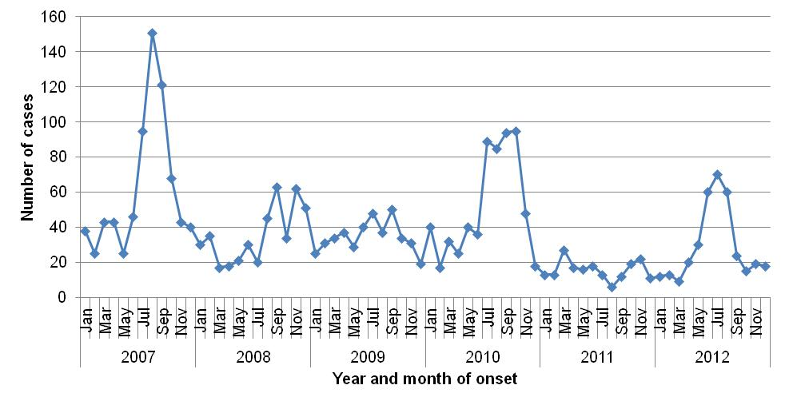
Figure 10. Number of cases of rotavirus infection by year and month of onset, WA, 2007 to 2012
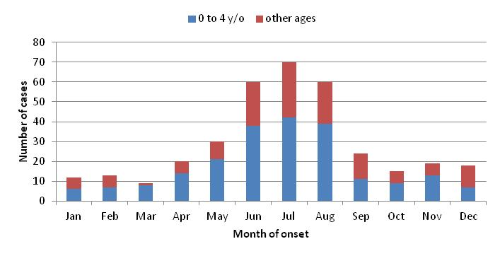
Figure 11. Number of notifications by month in 2012, for children in the 0 to 4 age group, and for other ages

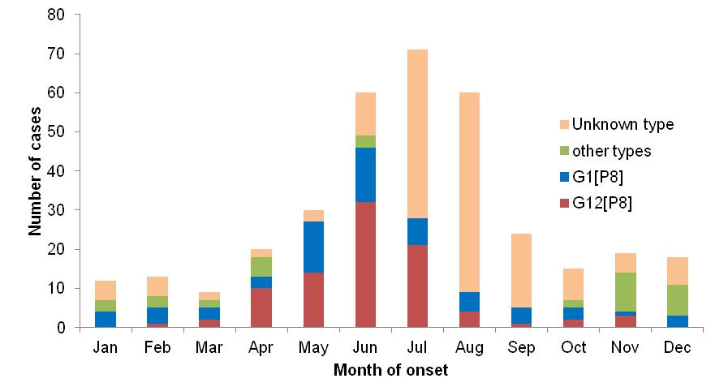
Figure 12. Rotavirus genotypes by month, 2012
As in previous years, the age group with the highest rotavirus notification rate in 2012 was the youngest age group, the <1- 4 years group (131 cases per 100 000 population), followed by the oldest age group, the 85+ years group (47 cases per 100 000 population) (Figure 13). The overall notification rate was similar for females and males (14.8 and 14.2 per 100 000, respectively).
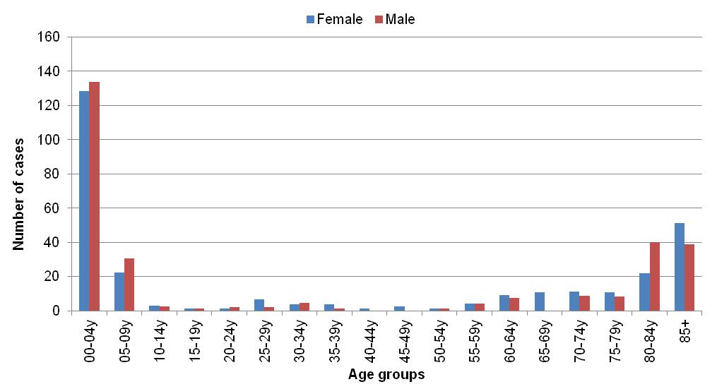
Figure 13. AAge-specific notification rates for rotavirus by sex, WA, 2012ge-specific notification rates for rotavirus by sex, WA, 2012
The regions with the highest rotavirus notification rates in 2012 were the Kimberley and Pilbara (70.5 and 42.4 cases per 100 000 population, respectively) (Figure 14). Overall notification rates were 4.5 times higher for Aboriginal than for non-Aboriginal people (55 and 12 per 100 000 population, respectively).
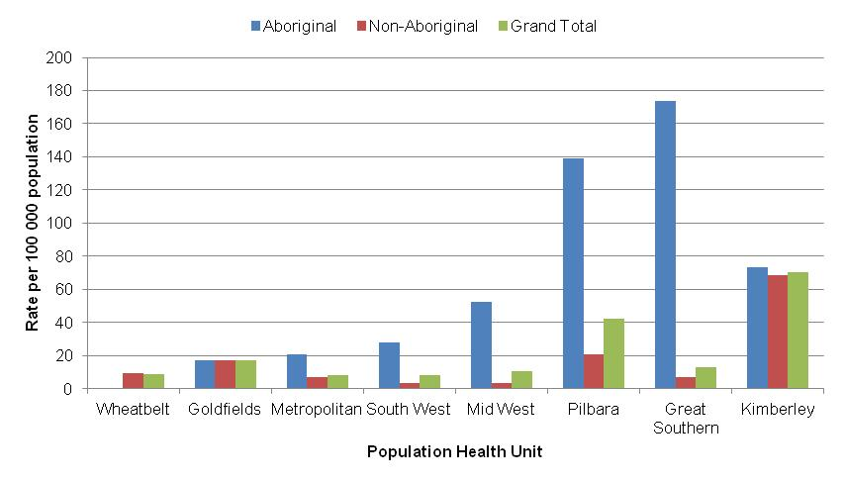
Figure 14. Rotavirus notification rates by region and Aboriginality, WA, 2012

Cryptosporidiosis
There were 168 cryptosporidiosis cases notified in 2012 (6.9 per 100 000 population). The notification rate was 64% lower than for 2011, and 42% lower than the mean of the previous five years (19.2 and 12 per 100 000, respectively) (Appendix 1). In each of the years from 2007 to 2012 cryptosporidiosis case numbers were higher in the summer and early spring, but in 2007 and 2011 case numbers were more elevated, with large statewide outbreaks (Figure 15). In 2012 case numbers were elevated in November and December, and this was caused by an outbreak in the Kimberley region, mainly in Broome.

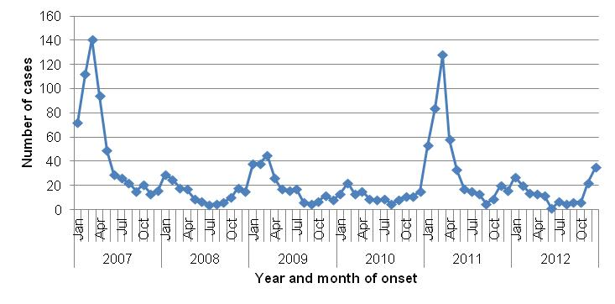
Figure 15. Number of cases of cryptosporidiosis by year and month of onset, WA, 2007 to 2012

The cryptosporidiosis notification rate was similar for females and males in 2012 (7.0 and 6.9 per 100 000 population, respectively) (Figure 16). The <1- 4 years age group had the highest notification rate (43 per 100 000 population), and accounted for 42% of all cryptosporidiosis notifications. The overall notification rate for the Aboriginal population was 7.8 times the rate for the non-Aboriginal population (42.9 and 5.5 cases per 100 000, respectively) (Figure 17). The Kimberley region had the highest notification rate (107 cases per 100 000 population), and the MidWest and Metropolitan regions the lowest notification rates (1.5 and 2.2 per 100 000, respectively).
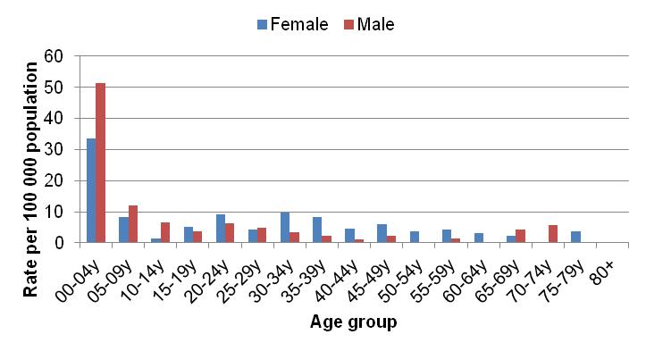
Figure 16. Age-specific notification rates for cryptosporidiosis by sex, WA, 2012
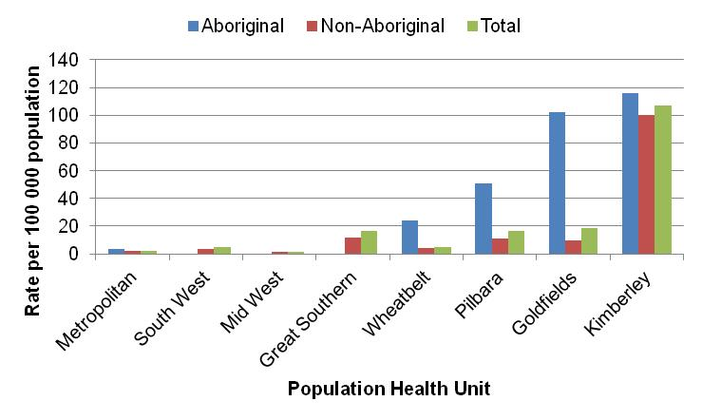
Figure 17. Cryptosporidiosis notification rates by region and Aboriginality, WA, 2012

Shigellosis infection
There were 53 shigellosis notifications in 2012, with a notification rate of 2.2 per 100 000 population, which was 40% lower than the previous year, and 50% lower than the previous five year average (Appendix 1). The number of notifications varied from month to month, with no clear seasonal pattern (Figure 18).
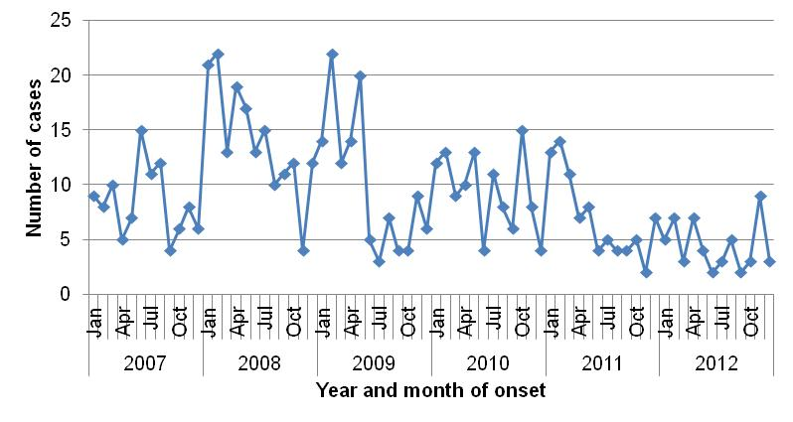
Figure 18. Number of cases of shigellosis by year and month of onset, WA, 2007 to 2012

The shigellosis notification rate was higher for females than for males in 2012 (2.6 and 1.9 per 100 000, respectively). Cases were relatively evenly distributed through the age groups (Figure 19). The population health region with the highest notification rate was the Kimberley (21 per 100 000 population). There were no shigellosis cases notified in the Wheatbelt or Great Southern regions of WA (Figure 20).
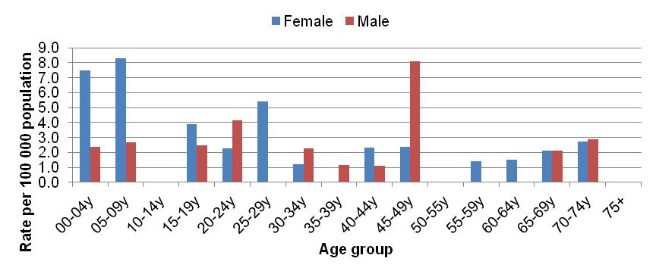
Figure 19. Age-specific notification rates for shigellosis by sex, WA, 2012
In 2012 the notification rate was 9.7 times higher for the Aboriginal population as compared to the non-Aboriginal population (16.9 and 1.7 per 100 000, respectively) (Figure 20). There was an 84% reduction in the number of shigellosis notifications for Aboriginal people from 2008 to 2012, and most of this reduction occurred in the remote regions of WA (Kimberley, Pilbara, Goldfields and MidWest) (Figure 21). Notifications for non-Aboriginal people also reduced by 50% during this time period.

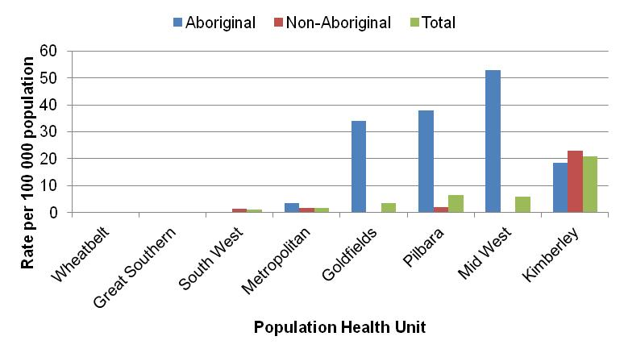
Figure 20. Shigellosis notification rates by region and Aboriginality, WA, 2012

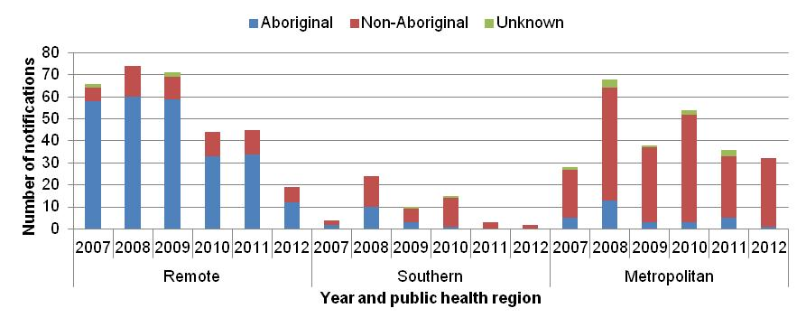
Figure 21. Year of onset and public health region of residence, for Aboriginal and non-Aboriginal shigellosis cases
The number of overseas acquired shigellosis cases remained relatively constant from 2007 to 2012, with the exception of 2010 when there was nearly double the number of overseas acquired cases notified (Figure 22). In 2012 Shigella sonnei was the most commonly notified species (19 cases, 54%). The most common S. sonnei biotype was biotype G, and most of the biotype G cases were overseas acquired. Nearly all of the remaining Shigella cases (23 cases, 43%) were infected with S. flexneri. A single case of S. boydii was reported, and no cases of S. dysenteriae were reported in WA in 2012.

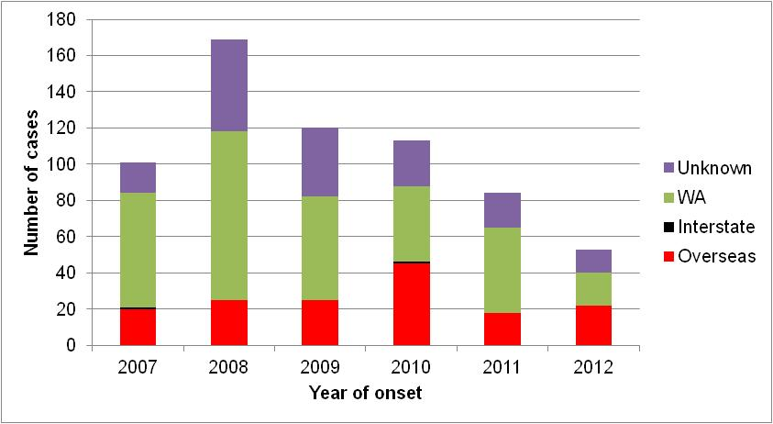
Figure 22. Place of acquisition for shigellosis cases, 2007 to 2012

Hepatitis A virus infection
There were 14 cases of hepatitis A notified in 2012 (0.6 cases per 100 000 population), which was similar to 2011, but a 47% reduction from the mean rate of the previous five years (1.1 per 100 000) (Appendix 1).
The age range for the 2012 cases was 10 to 67 years, and 11 of the cases were males (79%). All but one of the cases in 2012 was acquired overseas. Countries of acquisition were Indonesia (3 cases), India (2 cases) and China, El Salvador, Pakistan, Philippines, South Africa, Sri Lanka, Thailand and Western Europe (1 case each). The one locally acquired case was a family contact of a case who had acquired their infection overseas. There has been a marked reduction in the locally acquired hepatitis A cases in WA since 2009 (Figure 23).
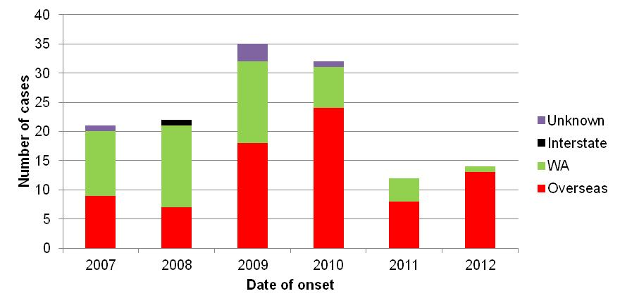
Figure 23. Place of acquistion for hepatitis A cases, 2007 to 2012

Typhoid and Paratyphoid fever
In 2012, there were 18 reported cases of typhoid fever (caused by Salmonella Typhi) which was a 64% increase in the mean rate of the previous five years (Appendix 1). This is also the most number of annual typhoid fever notifications that have been recorded in WANIDD (since 1990). Most cases had recently travelled overseas prior to illness and countries included India (n=8), Indonesia (n=8) and Sri Lanka (n=1). The case who had no recent travel history was a 60 year old male who was born overseas, had chronic renal failure and S. Typhi was repeatedly cultured from urine, indicating the person was a chronic carrier. Of the 18 cases, 12 were born in countries where typhoid is endemic, 61% were male and had a median age of 26 years (range 3-60 years). Nine cases of paratyphoid fever were notified in 2012 which included seven cases of S. Paratyphi A (four PT 1 and two PT6 and one not phage typed) and two cases S. Paratyphi B. All cases had overseas acquisition and countries included India (n=3), Indonesia (n=4) and South America (n=2). Six of the nine cases were born in countries where paratyphoid is endemic.

Listeriosis
There were eight cases of listeriosis due to Listeria monocytogenes infection notified in 2012 which is similar to the previous five year average of seven cases per year. Seven cases were non-pregnancy related (5 females and 2 males) and ranged in age from 57 – 86 years. While four cases had immunocompromising illnesses, and one case routinely took stomach acid lowering medication, the other two cases did not have underlying risk factors for infection. There was one maternal Listeria isolation (Figure 24) and the baby survived. All cases reported eating foods considered to be high risk for Listeria infection. Three of the cases are part of a cluster (see Cluster investigation section 5.3).
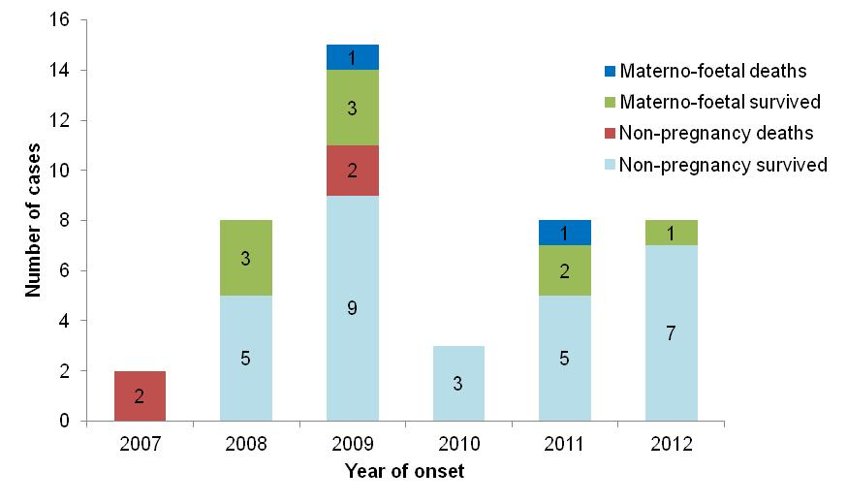
Figure 24. Notifications of listeriosis showing non-pregnancy related infections and deaths, and materno-foetal infections and deaths, WA, 2007 to 2012.

Vibrio parahaemolyticus infection
There were 14 cases of Vibrio parahaemolyticus infection in 2012 compared to the five year average of 10 cases. Of the 14 cases, 50% were male and the median age was 53 years (range 26-74 years). Eleven cases developed gastroenteritis after travelling overseas (Thailand [4], Indonesia [3], Malaysia [2], China [1], and Hong Kong [1]). Three cases had locally acquired wound infections.

Yersinia infection
There were three case of Yersinia enterocolitica infection notified in 2012 with two females and one male with ages 9, 71 and 86 years. Cases had not travelled prior to illness and all were from the Perth metropolitan area.

STEC infection
In 2012, there was a single case of STEC notified in a 22 year old female with no recent travel overseas who lived in a rural town.

Cholera, Botulism and HUS
There were no cases of cholera, botulism or HUS notified in WA in 2012.

Gastrointestinal disease outbreaks and investigations

Foodborne/suspected foodborne outbreaks
There were 14 foodborne or suspected foodborne gastroenteritis outbreaks investigated in WA in 2012 (Table 2). This includes two multi-jurisdictional outbreaks with one outbreak due to almonds contaminated with Salmonella, with six WA cases investigated and a total of 40 cases Australia wide. The other multi-jurisdictional outbreak was due to cheese contaminated with Listeria with one WA case investigated and a total of 31cases Australia wide (as of 26/3/2013). The 14 foodborne outbreaks caused at least 229 WA cases and four hospitalisations. Short descriptions of these outbreaks are described in 2012 quarterly reports (see www.public.health.wa.gov.au/3/605/2/ozfoodnet_enteric_infections_reports.pm).
In the previous five years (2007 to 2011) there was an average of 10 (range 4-17) foodborne or suspected foodborne outbreaks.

Aetiology
Of the 14 outbreaks, six were caused by unknown pathogens, two outbreaks by norovirus and one outbreak each was caused by Salmonella Anatum, STM PFGE type 39, STM PFGE type 434, STM PFGE type 436, Listeria and Campylobacter. Of the six outbreaks with unknown aetiology, the clinical illness, duration of illness and incubation period indicated that four could have been due to norovirus and two could have been caused by toxin mediated food borne illness.
In the previous five years, Salmonella species caused most (n=24, 47%) outbreaks, followed by norovirus (n=13, 26%), four toxin mediated-like outbreaks, one norovirus-like outbreak, and one due to unknown aetiology.
Food vehicles
The investigations of the 14 outbreaks identified food vehicles for ten outbreaks which included three outbreaks implicating dishes containing fresh produce (Salmonella associated with salad, Salmonella contaminated raw almonds and norovirus associated with grapes) and six outbreaks with a range of dishes including chicken (STM PFGE type 39), sandwiches (norovirus-like outbreak), multiple foods from a bakery (norovirus), pickled octopus/prawns (norovirus), pork belly (aetiology unknown), cheese (Listeria) and liver pate (Campylobacter).
In the previous five years there were 51 foodborne or suspected foodborne outbreaks and food vehicles were identified for 22 (43%) outbreaks. Of these 22 outbreaks, the most common implicated foods were dishes; containing eggs in 10 outbreaks, chicken in four outbreaks, fresh produce in three outbreaks, and five outbreaks implicating a range of dishes. Of the 29 outbreaks with unknown food vehicles, the aetiological agents included Salmonella (n=12), norovirus (n=10), Cyclospora (n=1) and Clostridium perfringens (n=1).
Evidence
The evidence that supported that the 14 investigations of enteric outbreaks were due to foodborne transmission including the implication of specific foods using analytical (case-control, cohort) studies for four outbreaks, case series for eight outbreaks and in three of these outbreaks the aetiological agent was identified in the implicated food. For the eight outbreaks investigated by a case series there was strong circumstantial evidence suggesting foodborne transmission i.e. people with the same illness had independently eaten food from a common food business. For one outbreak, no formal study was carried out as only three of a group of 12 people possibly exposed to contaminated food were willing to provide information.
For the previous five years the evidence used to support that 51 outbreaks were due to foodborne transmission was obtained using analytical (case-control, cohort) studies for 19 (37%) outbreaks, cases series for 31 (61%) outbreaks and in six of these outbreaks the aetiological agent was identified in the implicated food. No formal study was carried out for one outbreak as the tourists who where ill in this outbreak had left the country prior to being interviewed.
Food preparation settings
The setting where food was prepared for the 14 foodborne outbreaks in 2012, included four (36%) restaurants (caused by norovirus, Campylobacter, Salmonella, and unknown aetiology), two bakeries (caused by norovirus and suspect norovirus-like pathogen), two commercial caterers (suspect norovirus-like pathogens), one was primary produce (almonds- STM PFGE type 434), one was chicken meat prepared in the home (STM PFGE type 39) one was commercially manufactured (Listeria), one takeaway (caused by Salmonella), one in an aged care facility (suspect toxin mediated) and a camp (norovirus).
In the previous five years, the most common setting where food was prepared among the foodborne outbreaks was restaurants (n=25, 49%), followed by commercial caterers (n=5, 10%), aged care (n=4, 8%), private residence (n=3, 6%), takeaway (n=3, 6%) and cruise ships (n=3, 6%).
Major factors for contamination of food
The major factors for the contamination of food for the 14 outbreaks in 2012 was person to food to person transmission (n=6), which both involved sick people handling or in close contact with food. These six outbreaks were due to norovirus (n=1) or suspected norovirus-like pathogen (n=5). Contributing factors for the other outbreaks included cross-contamination of foods with raw ingredients (n=2), ingestion of contaminated raw products (n=1), storage in a contaminated environment (n=1) and inadequate cleaning of equipment (n=1). No contamination factors could be identified for three outbreaks.
The major factors for contamination of food in the 51 outbreaks in the previous five years was also person to food to person transmission (n=8). These eight outbreaks were due to norovirus. There were six outbreaks where the contributing factor was cross-contamination of foods with raw ingredients and four of these outbreaks were due to Salmonella species. Two outbreaks were caused by egg dishes suggesting the contributing factor was contaminated eggs, and the contributing factor for one outbreak was eating toxic substance (lupin flour). There were 34 outbreaks with no identified contributing factor.
Significant outbreaks
Salmonella Typhimurium PFGE 39 (outbreak code 042-2010-006)
There were 9 cases of STM PFGE type 39 (PT 135a) notified with onset dates in December 2010, which was significantly higher than the monthly average number of cases from July 2007 to November 2010 (2 cases per month). In January 2011 an epidemiological investigation was commenced by OFN, which involved interviewing cases about the foods eaten in the 7 days prior to becoming ill. Prior to this investigation, there were 21 isolations of STM PFGE 39 from non-human sources, 19 from chicken, one from small goods effluent, and for one no details were provided. A number of STM samples isolated from day old chickens were found to be positive for STM PFGE type 39 in September and October 2011. Based on these results, the FU began an environmental investigation including meeting with chicken meat producers. OFN continued to interview cases with more detailed questions on chicken consumption.
The outbreak commenced in December 2010 and peaked in December 2011-January 2012 and decreased to background levels in July 2012 (Figure 25). There were 128 STM PFGE type 39 cases with onset dates from December 2010 to June 2012. This was one of the largest foodborne outbreaks reported in WA.
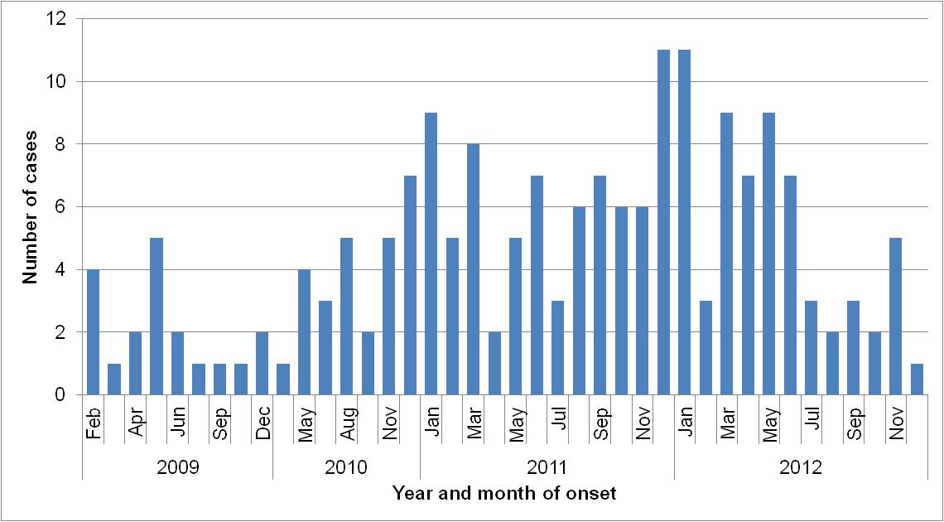
Figure 25. Year and month of onset for STM PFGE type 39 cases, 2010 to 2012
Of the 76 people interviewed, 69 (91%) reported eating chicken. This compared to 80% for other Salmonella cases interviewed with the same questionnaire, indicating that chicken consumption in the STM PFGE type 39 cases was elevated and was a possible risk factor for becoming ill. In addition to eating chicken, working in the poultry industry was identified as a risk factor for some cases. One case reported working at a retail poultry meat outlet prior to their illness onset, one case reported working at a chicken hatchery prior to their onset, while the mother of another case, also worked at a chicken hatchery and had brought chicks from the hatchery to their home.
Case interviews were ceased in August 2012, following a reduction in the number of notifications of STM PFGE type 39 to background levels which indicated that interventions were successful in reducing STM PFGE type 39 contamination in chicken meat.

Table 2, Foodborne and suspected foodborne outbreaks, 2012

1: Month of outbreak is the month the outbreak was first report or investigated, whichever is earliest
*PT = phage type, PFGE=pulsed field gel electrophoresis
# D = descriptive, M= microbiological, A=Analytical, DK=Don’t know

Outbreaks due to non-foodborne transmission or with an unknown mode of transmission
There were 113 outbreaks of gastroenteritis reported in 2012 that appeared to be non-foodborne including one suspected waterborne outbreak and 19 outbreaks were the mode of transmission was unclear or unknown.
Non-foodborne outbreaks
Of the 113 non-foodborne outbreaks, there was one suspected waterborne outbreak caused by Cryptosporidium associated with a rural public swimming pool. The remaining 112 outbreaks were suspected as person to person transmission, 79 (71%) of which occurred in residential care facilities, 22 (20%) in hospitals, six (5%) in child care centres, three at institutions (3%) and one each at a school (1%) and on a cruise ship (1%) (Table 3). The causative agent for 76 (68%) of the outbreaks was confirmed as norovirus and three (3%) outbreaks were due to rotavirus. In the remaining outbreaks (29%) the causative agent was unknown, either because a pathogen was not identified during testing, specimens were not collected, or viral testing was not requested. A total of 3065 people were affected by these outbreaks, with 67 hospitalisations and 14 deaths.
The number of non-foodborne gastroenteritis outbreaks in 2012 was a 45% increase on the number of outbreaks in 2011 (n=77), and similar to the average of the previous five years (n=115). While the number of gastroenteritis outbreaks reported varied by month (Figure 26), there was no distinct seasonal increase in the number of outbreaks, as was seen in previous years.
Outbreaks with unknown mode of transmission
In the remaining 19 outbreaks the likely mode of transmission was unclear or unknown, with 16 (84%) occurring in aged care facilities, and one each at an indoor play centre (5%), a camp (5%) and a private residence (5%) (Table 3). Below are descriptions of these outbreaks.
- There were 16 outbreaks in aged care facilities where diarrhoea was the predominant or only symptom. The mode of transmission in these outbreaks was not norovirus-like and therefore described as unknown rather than person-to-person. Most of the outbreaks (12/16) had specimens tested which were negative for common bacterial and viral pathogens. One outbreak with 14 ill residents had two specimens positive for Clostridium perfringens but the isolates were discarded before PFGE typing could be done.
- Throughout September, there was an outbreak at a mining camp affecting 47 people. Symptoms of vomiting and diarrhoea were reported but no specimens were tested. There was insufficient information to determine the mode of transmission.
- In March, there was a party at indoor play ground and 22 of 42 people were ill. Cases had vomiting and diarrhoea but no specimens were collected. Party food was catered by play centre but food was served hot.
- Four members of one household were ill with diarrhoea and abdominal pain, and two confirmed with STM PFGE 39. Onset dates were over five days. The grandmother, who lived separately, was also positive for STM PFGE 39. The grandmother and other family members had not eaten together in the week before illness. It is unclear whether the family were exposed to the same contaminated food or if person-to-person transmission was responsible for (at least some of the) illness.
Table 3. Outbreaks of non-foodborne transmission or unknown mode of transmission in WA by setting and agent, 2012

¹ NR= data not recorded
² Deaths temporally associated with gastroenteritis, but contribution to death not specified

Figure 26 . Number of gastroenteritis outbreaks designated as non-foodborne or with unknown mode of transmission reported in WA, 2007 to 2012

Cluster investigations
In 2012, there were five Salmonella clusters and one Listeria cluster investigated (see Table 4) which are described in 2012 quarterly reports (www.public.health.wa.gov.au/3/605/2/ozfoodnet_enteric_infections_reports.pm).
Significant clusters
Salmonella Infantis
Clusters of Salmonella Infantis were investigated in February (21 cases) and in September (5 cases). S. Infantis was the fifth most common Salmonella serotype in 2012. In both investigations, a hypothesis for the cause of illness was not established. The two clusters had slightly different demographics. In the February cluster, 52% of cases were female, median age was 19 years (range <1-60 years) and 81% lived in metropolitan Perth area. In the September cluster, 100% were female, the median age was 54 years (range 13-76 years) and 100% lived in metropolitan Perth area.

Listeria
In December 2012, three cases with the same Listeria type (serotype 1/2, binary type 82, PFGE type 8H:110A:2T) were investigated. The cases were all female, aged 57, 80 and 28 years with onset of illness 25/2/12, 12/11/12 and 24/11/12, respectively. The 28 year old was pregnant and gave birth to healthy baby at 36 weeks gestation. The cases did not report eating at any common food businesses, and foods eaten in common by 2 of 3 cases was rockmelon, watermelon, strawberries, bagged salad, brie/camembert and yoghurt. The case with an onset of 25/2/12, had cheddar and fetta samples positive for Listeria and the fetta isolate was the same type as the case. However, these cheese samples were opened packets and recovered from a rubbish bin, so the significance of these findings was unclear. The other two cases did not report eating fetta.

Table 4. Cluster investigations in WA by month investigation started, setting and agent, 2012

*PT = phage type, PFGE=pulsed field gel electrophoresis

OzFoodNet WA research projects

Cryptosporidium project
A case-control study of sporadic Cryptosporidium cases was started in June 2010 to determine risk factors for infection. The recruitment of participants has been completed with 204 cases and 612 controls enrolled. Molecular typing of Cryptosporidium positive specimens is also being conducted by Murdoch University. The data will now be analysed and published in peer-review journals.

Review of Guidelines for the Management of Gastroenteritis Outbreaks in Residential Care Facilities
In Dec 2010 a review of the “Guidelines for the Management of Gastroenteritis Outbreaks in Residential Care Facilities” was commenced. Meetings were held with WA partners in residential care to seek comment on the present guidelines, and on processes for managing gastroenteritis outbreaks, including roles, responsibilities and reporting, to identify what could be improved. Groups consulted were the WA Health public health staff, infection control consultants, the WA office of Aged Care Quality and Compliance, Commonwealth Department of Health and Ageing, residential care peak bodies (Aged and Community Services WA and Aged Care Association of WA), WA Health Aged and Continuing Care Directorate, and the Aged Care Standards and Accreditation Agency. As a result of this consultation a draft 2nd edition of the guidelines has been produced, and will be circulated to aged care facilities and stakeholders in 2013.

Joint co-ordination of national case series study of Salmonella Typhimurium PT 193
In 2009 a large increase in the number of notifications of STM PT 193 was observed nationally. This increase was predominantly seen with isolates of STM PT 193 that were resistant to ampicillin, streptomycin, tetracycline and sulphonamide (ASTSu). Increases in STM PT 193 and monophasic Salmonella PT 193 were also noted in the northern hemisphere, where the increase appears to be linked to pork consumption. A national cluster investigation was commenced in September 2011 and involved interviewing cases of STM PT 193 and monophasic Salmonella PT 193 with ASTSu with a questionnaire focussing on consumption of pork and beef products. A total of 85 cases were recruited, with a median age of 9 years, with 47% female and 52% male cases. Food consumption in cases was compared to historical Salmonella case food frequency databases in WA and Hunter, NSW, but no strong hypothesis for the possible cause of the Australian increase in these Salmonella types was determined. Further analyses of the data, including individual jurisdictional analyses and laboratory characterisation of the isolates, are pending.

References
- Hall G, Kirk MD, Becker N, Gregory JE, Unicomb L, Millard G, et al. Estimating foodborne gastroenteritis, Australia. Emerg Infect Dis 2005;11(8):1257-1264.
- OzFoodNet Working Group. A health network to enhance the surveillance of foodborne diseases in Australia. Department of Health and Ageing 2013. www.ozfoodnet.gov.au/internet/ozfoodnet/publishing.nsf/Content/Home-1 [14/03/2012]
- Western Australian Department of Health. A-Z list of case definitions. Western Australian Department of Health 2013. www.public.health.wa.gov.au/2/243/3/infectious_diseases_az_for_health_professionals.pm [14/3/2012]
- National notifiable disease surveillance system. National case definitions. Department of Health and Ageing 2013. www.health.gov.au/internet/main/publishing.nsf/content/cda_surveil-nndss-dislist.htm [14/03/2012]
- Western Australian Department of Health. Contact details for regional population / public health units. Western Australian Department of Health 2013. http://www.public.health.wa.gov.au/3/280/2/contact_details_for_regional_population__public_he.pm [05/04/3012].
- Caillere N, Vilain P, Prottet E, Kaplon J, Ambert-Balay K, Polycarpe D, Filleul L. A major outbreak of gastroenteritis in Reunion Island in 2012: first identification of G12 rotavirus on the Island. Eurosurveillance 2013:18(19).

Appendix 1: Number of notifications, notification rate and ratio of current to historical mean by pathogen/condition, 2007 to 2012, WA

¹Abbreviations: STEC: Shiga-toxin producing E. coli; HUS: Haemolytic Uraemic Syndrome. Rate is cases per 100 000 population. Mean of rates between 2007 and 2011.
This document can be made available in alternative formats on request for a person with a disability.

© Department of Health 2013

